CAMP CACHALOT

2002 Leaders/SPL Guidebook





Fifty-Six Years
of Scout Camping
1946-2002

A
SEMCA
MEMBER
COUNCIL

Camp Cachalot

BOY SCOUTS OF AMERICA
New Bedford, MA 02740
(508) 993-9978

March 22, 2002

FROM THE CAMP DIRECTOR

Dear friends in scouting,

Welcome to another season at Camp Cachalot. This is your leader Guidebook for the 2002 season. We hope that all of your questions and concerns will be answered in this booklet. Please take the time to read the guidebook. We have made some changes in our program but only to enhance the areas. We are working hard to improve the sites and areas to better serve your troop.

Our staff at Camp Cachalot is one of the best and their enthusiasm will be passed on to your scouts. We have many of our returning staff and a few new faces. We believe that this will be one of our greatest summers at camp and our staff is working hard to make it happen for you and your troop.

I am honored to be Camp Director of such a great camp and to have the support of all of the troops and staff members. It will be a great pleasure to serve you this Camp Season. My goal is to make an unforgettable camping experience for you and your scouts. I look forward to seeing all of you this summer.

Yours in scouting

Linda Bishop
Camp Director
Camp Cachalot

TABLE OF CONTENTS

FROM THE CAMP DIRECTOR 2
CAMP FEES 5
TROOP LEADERSHIP 5
PAYMENT PLAN 6
INDIVIDUAL CAMPING 6
PRIOR PLANNING 7
PLANNING CHECKLIST 8
BEFORE YOU GO 8
PARENTS’ MEETING 9
WHAT YOUR TROOP SHOULD BRING 9
DAMAGED EQUIPMENT 9
CONSERVATION 9
YOUR CAMPSITE 10
UNIT LEADER ARRIVAL TIME 10
CAMPSITE Maximum and Minimum sizes 10
PHOTOGRAPHS 10
CAMP EVALUATION FORM 10
MEDICAL FORMS 11
FIRST AID 11
HEALTH & SAFETY (Q&A) 11
STOVE & LANTERN USE 12
FIREWORKS, FIREARMS & ARCHERY 12
ALCOHOL, DRUGS & SMOKING 12
RELIGIOUS SERVICES 12
HOW TO GET THERE 13
CAMP MAP 14
CAMP EMERGENCY PROCEDURES 15
EXPRESS CHECK IN 16
DAILY PROGRAM SCHEDULE 17
OPERATIONAL TIMES 18
FLAG CEREMONIES 18
HEALTH AND REST 18
UNIFORMING 19
VISITORS 19
MAIL 19
TELEPHONE 19
DINING HALL PROCEDURES 20
ASST. RANGER PROGRAM & HOME REPAIR MERIT BADGE 21
GOOD TURNS 21
GUIDELINES FOR YOUTH PROTECTION 21
SCOUTING: A GAME WITH A PURPOSE 22
AFTERNOON EVENTS 22
EVENING EVENTS 23
EVENING PROGRAM SCHEDULE 24
ADVANCEMENT PLANNING 25
COUNSELOR IN TRAINING (C.I.T.) 26
2002 EAGLE QUEST 27
MERIT BADGE MIDWAY 28
AQUATICS 29
THE ECOLOGY CONSERVATION AREA 31
HANDICRAFT 33
SCOUTCRAFT 35
FIELD SPORTS 37
AFTERNOON GAMES 39
CACHALOT PROGRAM SURVIVE (Ca.P.S) 40
HEALTH LODGE 40
SCUBA DIVING CERTIFICATION SPECIALTY CAMP 41
MOUTAIN BIKE PROGRAM 41
ADULT LEADERS 41
SECOND CUP OF COFFEE 42
FIRESIDE CHAT 42
VEHICLES IN CAMP 42
HOW CAN YOU HELP? 43
CAMPSITE INSPECTIONS 43
FIELD TRIPS 43
DEPARTURE 44
SCHEDULE 46
PARENTS APPENDIX 47
WHAT TO BRING TO CAMP 47
WHAT NOT TO BRING TO CAMP 47
POCKET MONEY AND OTHER COSTS AT CAMP 48
LOST AND FOUND 48
PHOTOGRAPHS 48
RELIGIOUS SERVICES 48
2002 EAGLE QUEST 49

CAMP CACHALOT SUMMER CAMP DATES

Week One: July 7-13
Week Two: July 14-20
Week Three: July 21-27
Week Four: July 28- Aug. 3

CAMP FEES

All Scouts with their Troop $212.00 per Scout (in Council & SEMCA)
$226.00 per Scout (out of Council)

Camp provides central dining hall meals, limited campsite equipment, program equipment and areas, plus the best camp staff going!

Provisional Campers in Cadre Troop: $219.00 per Scout

Camp provides everything that is part of the council troop plan plus trained adult leadership.

2002 Special - 2nd Week of Camp for $10.00 less each week

Scuba Certification Week 5 $200.00 – Due by June 1, 2002 Venture Week
Eagle Week Week 4 $212.00 1st or $202.00 2nd week must stay with Eagles.

Family Discount:
Families with more than one scout will receive an additional discount per scout beginning with the second family member going to summer camp. Save $10.00 per additional scout.

TROOP LEADERSHIP

➢ Every troop in camp must be under the supervision of its own adult leaders.
➢ One leader must be at least 21 years of age and registered with the Boys Scouts.
➢ The other leader must be at least 18, be registered and possess some leadership skills.
➢ These two adults must be in camp at all times to assume responsibility for their Scouts.

Leader Fees:
The first two leaders are free. (in or out of council)
For troops with 21 to 30 scouts another leader can be added free
For troops with over 30 scouts, another leader can be added free.
Additional leaders add an extra $100.00 per leader over the amount for free.

Helpful Hint:
➢ Start scheduling your leaders now.
- We suggest one additional leader for every 10 Scouts over 20.

PAYMENT PLAN

Cachalot Scout Reservation presents the 2002 Incentive Hat. We are celebrating Cachalot 2002 with a 6-panel premium soft cotton twill cap. The cap boasts a pre-curved extended visor, deluxe 4-row stitch sweatband, a hidden brass buckle rivet and comes complete with a belting leather strap. The low profile khaki and blue cap will be embroidered with "CAMP Cachalot 2002" on the front. Your Scouts will wear this cap long after camp is over and the cap surely will be a collector's item for future generations.
Your Troop can hike, earn merit badges, camp, and have fun at Cachalot this summer, wearing this quality cap with pride. All you have to do is submit to Cachalot Scout Reservation a $ 25.00 deposit for each scout that will be camping at Cachalot this summer. The deadline is April 16, 2002. Each Troop that takes advantage of this fantastic offer will receive two extra caps for their adult leaders. A troop roster is not necessary to take advantage of this offer.
That is not all. We will offer to any Troop that wants to personalize their Cachalot 2002 cap an extra special offer. We will have embroidered on the back of the cap one line up to 9 letters for $ 3.50 per cap or two lines up to 9 letters per line for $ 4.50 per cap. What you want on the back of the cap is up to you. All of your Troop caps will read the same. Don't wait; the deadline for this limited offer is April 16, 2002. All payments for extra embroidery must be made by this date. Hats will be available when you check in on Sunday.
The $25 deposit per Scout is non-refundable. Make sure that you do not deposit for more Scouts than you will bring to camp. For more information e-mail dwertz@narragansettbsa.org or call (401) 351-8700 EXT. 309

Camperships
Limited financial help may be available on an individual basis for Scouts who could not otherwise go to camp due to financial hardships. If you know of a legitimate case in your troop, please contact the Council Service Center for a campership application. These forms are to be filled out, approved by the unit leader, and submitted to the Service Center for review BEFORE JUNE 1st. APPLICATIONS RECEIVED AFTER THIS DATE WILL NOT BE APPROVED.
Campership funds are limited, so before applying for a campership, please be sure you have considered other financial resources, such as your chartered organization, unit fundraisers and other outside sources.

Refunds
In the case of hardships and emergencies, refunds can be requested.
Individual camp fees are refundable except for the $25.00 reservation portion of the fee, which is non-refundable. More definitive information on this will be available in the council and camp office.

NO REFUNDS WILL BE MADE IF REQUESTED AFTER YOUR TROOP LEAVES CAMP.

INDIVIDUAL CAMPING

If you have a Scout or Scouts who are unable to attend summer camp with your troop, please don’t let them miss the opportunity!
➢ Register them with our Provisional “Cadre” Troop during any camp week, for a cost of $219.00.
➢ Register them with another troop in your area where they may already know other Scouts.
The Cadre Troop is made up of a wide range of Scouts that either could not attend camp with their troop or are attending Cachalot for a second time. If a Scout would like to come back for a second week he may do so for a discounted cost of $209.00.
Cadre Scouts must be currently registered with and participating in a local troop. They must have a letter of recommendation from their Scoutmaster stating that they are not a discipline problem and that the Scoutmaster recommends them for Camp. Cadre Scouts not meeting the normal guidelines for Scouting will be asked to leave camp.

PRIOR PLANNING
The Key To Success!

The day you select your campsite you should:
1. Inform all Scouts, second year Webelos and their parents.
2. Recruit two adult leaders (more if you have 20 or more Scouts).
3. Take note of payment plan and make sure you stay on target with money due (deposit of $25.00 due by April 16, 2002; remainder of fees due 16 days prior to your arrival at camp.)
April, May and June:
1. Send out final camp notices to parents.
2. Have committee members visit parents of Scouts not registered to encourage their attendance.
3. Develop a program of activities using this guidebook, S.M. Handbook, Scout Handbook, Fieldbook, Woods Wisdom and Wood Badge Training Material.
4. Provide Scouts and parents with a list of what to bring.
- Consider each Scout’s needs for advancement.
- You will receive an express check in time at the Tuesday night Scoutmasters meeting to be held at camp on the Tuesday night prior to your week at camp. This will be your reserved time for your troop to arrive at camp. This will allow us to better serve you.

Three weeks before camp you should:
1. Finalize program of activities your troop would like to undertake.
2. Collect and review all Scout and Leader Medical Forms.

IMPORTANT - Remember each form must be signed by a licensed physician and the parent of the Scout, and be up to date. If a person does not have a physical form completed correctly, he will be asked to get a physical exam at his or her own expense upon arrival.
This is a National BSA policy as well as a state law. NO EXCEPTIONS!

A few days before camp you should:
1. Hold inspection of personal packs and equipment.
2. Lay out troop equipment and get ready for packing.
3. Prepare multiple copies of your troop roster (for camp, other leaders, SPL, etc.).
4. Complete final check on transportation.
5. Remind Scouts of behavior standards of your troop, camp as well as the Scout Oath and Law.
6. Remind Scouts to pack a sack lunch for Sunday unless you plan on stopping. No lunch is served at camp on Sunday.

Sunday – The day of departure you should:
1. Panic (just kidding, but, you might want to check your gas gauge…)
2. MAKE SURE EVERYONE HAS HIS MEDICAL FORM AND ANY MEDICATIONS!
3. Label all medications in their original containers with the Scout’s name and troop number. (This includes, aspirin, cough medicine etc.) State law requires all medication to be properly labeled and checked in at the health office.
4. Plan on arriving at camp with all of your Scouts just prior to the reserved check in time that you received in the mail. You will have a fifteen-minute window for your troop to meet with your staff guide and begin your check in. This is the only way we will be able to serve you for express check in.
- Make sure rides are planned for picking Scouts up on the following Saturday before 10:00 a.m.

PLANNING CHECKLIST

- Attend Summer Camp Orientation March 27, 2002
- READ THIS BOOK Sometime soon
- Promote camp to Scouts and parents Year Round
- Inform Scouts of medical information, equipment At Camp Promotion
needs, advancement and program goals. and / or election night
- Distribute list of what to bring Spring Troop Meetings
- Schedule O.A. Election and Promotion Before May 21,2002
- Review programs and activities Spring Troop Meetings
- Plan program with Patrol Leaders Council Spring Troop Meetings
- Scouts plan badges, rank advancement etc. Spring Troop Meetings
- FIRST PAYMENTS DUE ($25.00 PER SCOUT) APRIL 16, 2002
- FINAL PAYMENTS DUE 16 Days prior to arrival at camp
- Double check for medical releases, Saturday before you leave.
Medication and parent consent forms.
- Attend the Scoutmasters meeting at Camp on the Tuesday night Before 6:00PM
Tuesday night prior to camp and bring medical forms.
- Select week and site for following year. Between now and end of camp

BEFORE YOU GO

- Make sure certain promotional and informational material is shared with Scouts and parents.
- Promote use of our Web site www.narragansettbsa.org for downloads of manuals and forms.
- Use Cachalot’s Own Web site www.campcachalot.org for all camp information. (coming soon)
- Make sure Scouts and parents know what to bring, what activities to prepare for and what
advancement opportunities are offered.
➢ Patrols should have their flags ready.
➢ The Patrol Leaders Council should have activities and advancement opportunities planned.
- Parents need to know how much camp costs, payment plans, dates, mailing address, phone
number, etc.
- The Scoutmaster and Senior Patrol Leader should know all this and more, as they become the
“experts” on camp preparation.
- The Scoutmaster and the Senior Patrol Leader should attend the Tuesday night dinner meeting at
camp on the Tuesday night prior to camp at 6:00 to turn in medical forms and get the current
latest information.

PARENTS’ MEETING

Many troops hold a parent’s meeting or camp promotion night. This can be at a Court of Honor, special parent’s night, during a regular meeting or whenever convenient. This is important so that parents can ask their questions and learn what camp is all about. You may wish to ask your local Order of the Arrow Lodge to join you with their special camp promotion video. If you can’t answer a question, call the Council Service Center (508-993-9978). The important thing is to get all the questions answered.

Here is a sample agenda to help you plan:
➢ Welcome and Introductions
- Hand out an information sheet, Camp has a parent/scout guidebook available.
➢ Explain the dates, location, costs, etc.
➢ View Order of the Arrow promotion
➢ Explain program highlights, advancement program and visitor information.
➢ Question and Answer time
- Final Reminders and Closing

WHAT YOUR TROOP SHOULD BRING

Each troop and patrol is urged to bring its own equipment to enable the troop to have an independent operation in its own campsite. The following is a recommended list of equipment a troop could or should bring:

Lantern
Troop Flag
Patrol Flags
First Aid Kit
Dutch Ovens
Troop Library
Material to Teach Scouting Skills
Sharpening Stone and File
Map and Compass
Extra Sleeping Bag

DAMAGED EQUIPMENT

Cachalot Scout Reservation puts a very high value on its program and campsite equipment. Our goal is to use it for several years. To do so we need your help in maintaining it and practicing proper use with your Scouts. Any damage to camp-owned equipment through negligence and / or abuse will be the sole responsibility of the troop. Replacement costs will be assessed to the troop based on the retail costs of the damages item. Troops will be responsible for paying for any damaged items before leaving camp. Please be careful when using camp equipment.

CONSERVATION

Please take care of the natural resources at Camp Cachalot. Teach your Scouts not to cut any living tree, shrub or bush. Be careful with fire in your area. Make sure that they are attended until out and that the ground has been cleared the proper distance around it. Do not clear away ground cover other than around your 1/2 barrel. The ground cover helps to protect against the effects of erosion.

YOUR CAMPSITE

Each campsite is equipped and ready to go from the moment you walk into camp. A considerable amount of time and money has been invested to better prepare your campsite. Please take full advantage of your site and remember to take care of the canvas, table and environment of your site.
Your campsite will be provided with the following:

A Dining (patrol) Fly**
Toilet paper & Latrine cleaning material*
A Picnic Table
Flagpole & Flag
Bow Saw & Axe w/sheath**
Sharpening Stone**
Fire Barrel and Bucket**
Trash Barrel**
Camp Map & Compass**
Camp Shovel**

Each campsite is equipped with running water and a latrine.
*These items may be picked up at the dining hall, see the Site Provisions Outfitter.
**These items are in the patrol box or can be picked up with the Quarter Master

UNIT LEADER ARRIVAL TIME

Unit leaders wishing to arrive earlier than 1:00 PM for the purpose of setting up their campsite may do so, with prior notice to the Ranger and Camp Director. IMPORTANT: All vehicles MUST be out of camp by 12:00 NOON. The speed limit in camp is 5 MPH.! No vehicles will be allowed in Camp while Scouts are in camp. Staff members will be unable to assist Unit Leaders prior to 1:00 PM on Sunday because they are not on duty until that time.

CAMPSITE Maximum and Minimum sizes

Due to the variables in troop sizes, campsites have a minimum and maximum capacity. If a unit arrives in numbers significantly above or below the capacity of the campsite that they have reserved, the camp leadership reserves the right to switch, or ask the Unit to share campsites. Every effort will be taken to avoid this, but capacity may dictate the need. If you are unsure you will fit or have the minimum please contact the Camp Director for more information. Please work with us on this issue.

PHOTOGRAPHS

A photo of your Scout's troop is a great souvenir of camp! These color 8" x 10" troop photos will be taken on Monday before dinner. Please see your Unit Leader for ordering details. Photos will cost $7.00 each

CAMP EVALUATION FORM

At the end of your week at camp, we are going to ask you to give an evaluation of how camp was. We want to know what went well and what didn't We can only correct problems if we are aware of them and we appreciate realistic comments, good or bad. Your SPL will also be asked to complete an evaluation from the Scouts perspective. He should meet with his Troop and discuss the information prior to completing the form. Completed forms should be returned to us at the Camp Office.

MEDICAL FORMS

This year we will be using the same medical form as last year. It will consist of the standard Class 3-BSA medical form with a back section for camp information. Each Scout and Adult Leader in camp must have a medical examination by a physician within one (1) year of his/her arrival at camp. Because of the new medical forms and new regulations you must have a new physical this year. Only the camp medical forms will be used which will be available from the Council Service Center or by downloading them from of our web site. See the 2002 Forms Manual for a copy of the medical form.
Upon arrival at camp or Pre-Camp Planning Meeting , this medical form must be presented to the Camp Health Officer. As in past years, these Camp Medical Forms must be kept on file at the Council Service Center. If your unit or an individual Scout wishes to have this form for utilization at other events and activities, please be sure to have a copy made of this form prior to your arrival at camp. Unit leaders are asked to review each Scout's medical form prior to camp to insure that each parent and physician signed the form.
To accomplish Express Check In it is important that you bring your completed Scout Medical Forms to the Tuesday evening Program Planning Meeting at camp prior to your unit's arrival, so that the Camp Health Officer may have an opportunity to review these forms.
Scouts will not be allowed to stay in camp without a valid medical form on file. All adults must have record of a Mantoux test within the last 24 months before entering camp. This is the law of Massachusetts and a National BSA Policy.

FIRST AID

Immediate First Aid for all injuries is to be provided and then reported to the Camp Health Officer. Remember all injuries must be reported to the Camp Health Officer no matter how small they might seem.

HEALTH & SAFETY (Q&A)

In order to get your stay at camp off to a great start, we want to make sure all your Scouts and Leaders will complete the medical recheck station without any hassle. From experience in these situations, we would like to share some of the questions and concerns of previous years.

Q: Does the physical exam need to be completed on a certain BSA form?
A: Yes. This form will be mailed to Scouts with the Camp brochure, a copy will be in the Camp Forms Manual and it will be available at the Council Service Center and for download on our web site.

Q: Do we need to have a physical and a new form filled out this year?
A: Yes. This year will have a new form and all leaders should note this change.

Q: Does everyone need to turn medication in at the Health Lodge?
A: Yes. State Law requires that all medication be turned in to the health officer and that all medication be in its original containers with the original labeling and have the required dosage requirements. Special instructions should be explained to the Health officer. This does not include inhalers and epi pens. These must be registered with the nurse but can be carried with the scout.

Q: Do Adult Scouters (18 years and older) need a Mantoux test prior to attending camp?
A: Yes, State Law requires that adults 18 years and older are required to have had a Mantoux test for TB within the last 2 years.

STOVE & LANTERN USE

Due to the excessive hazards, which are involved with the storage of fuels used in lanterns and stoves, these materials must be stored with the Camp Ranger. Arrangements for refueling these devices must be coordinated with the Camp Ranger through the Camp Commissioner.
Additionally, the camp tentage is fire resistant, but not fire proof. For obvious reasons, no open flames or flammable materials are allowed in the tents. This includes stoves, gas or kerosene lanterns, candles or any other such flammable devices. The use of such things as charcoal stoves in and around tentage adds to the danger of carbon monoxide poisoning. All stoves and lanterns are to be used by Adult leaders only.

FIREWORKS, FIREARMS & ARCHERY

All fireworks and other explosive materials are forbidden in camp. Anyone caught with these items will be subject to immediate dismissal from camp. Personal firearms and ammunition, as well as archery equipment, are not allowed in camp except under the supervision of the Shooting Sports Director. All personal equipment must be turned over to the Shooting Sports Director upon arrival at camp. ABSOLUTELY PROHIBITED: SLINGSHOTS, CO₂ GUNS, HAND GUNS, BB GUNS, CROSS BOWS, PAINTBALL GUNS.

ALCOHOL, DRUGS & SMOKING

No alcoholic beverages are allowed in Camp. This applies to all members of our camp community, as well as visitors to Camp Cachalot. In addition, contraband drugs and/or substances are not permitted.
All Prescription drugs or substances must be stored with and issued by the Camp Health Officer. All non-prescription medications must be checked in with the Camp Health Officer. Anyone caught with drugs/alcohol will be subject to immediate dismissal of camp.
It is the responsibility of the Boy Scouts of America to protect the health of the young people in our program. It is the policy of the Boy Scouts that leaders should not use tobacco products in any form in the presence of youth members. Therefore, all buildings or facilities under control of the local council area are designated as non-smoking facilities. Smoking outside entrance/exit doors is not permitted in any location. In addition, all Scouting functions, meetings, and activities should be conducted on a smoke-free basis.

RELIGIOUS SERVICES

ROMAN CATHOLIC
On Sundays at 5:15 PM, before the Bar-B-Que supper there will be a Roman Catholic Service for those wishing to attend. This will be held in the Chapel behind the Cook's Cabin. All camp activities will begin after this service is completed. You are also welcome to use the Chapel for services, to pray as a unit or an individual.

INTER-FAITH (Scout Vespers)
An Inter-Faith service will be held on Thursday nights at 6:30. This will be held in the Chapel behind the Cook's Cabin. This service will be designed for all religions. All camp activities will begin after this service is completed. You are also welcome to use the Chapel for services, to pray as a unit or an individual.

HOW TO GET THERE

“It’s always good to know…”
1. From the West, New Bedford and Fall River - Take I-195 E to Route I-495 N. Take I-495 N to Route 58 N then follow instructions #3 below.

2. From the North, Taunton - Take I - 495 S to route 58 N then follow the instructions below.

Camp Cachalot

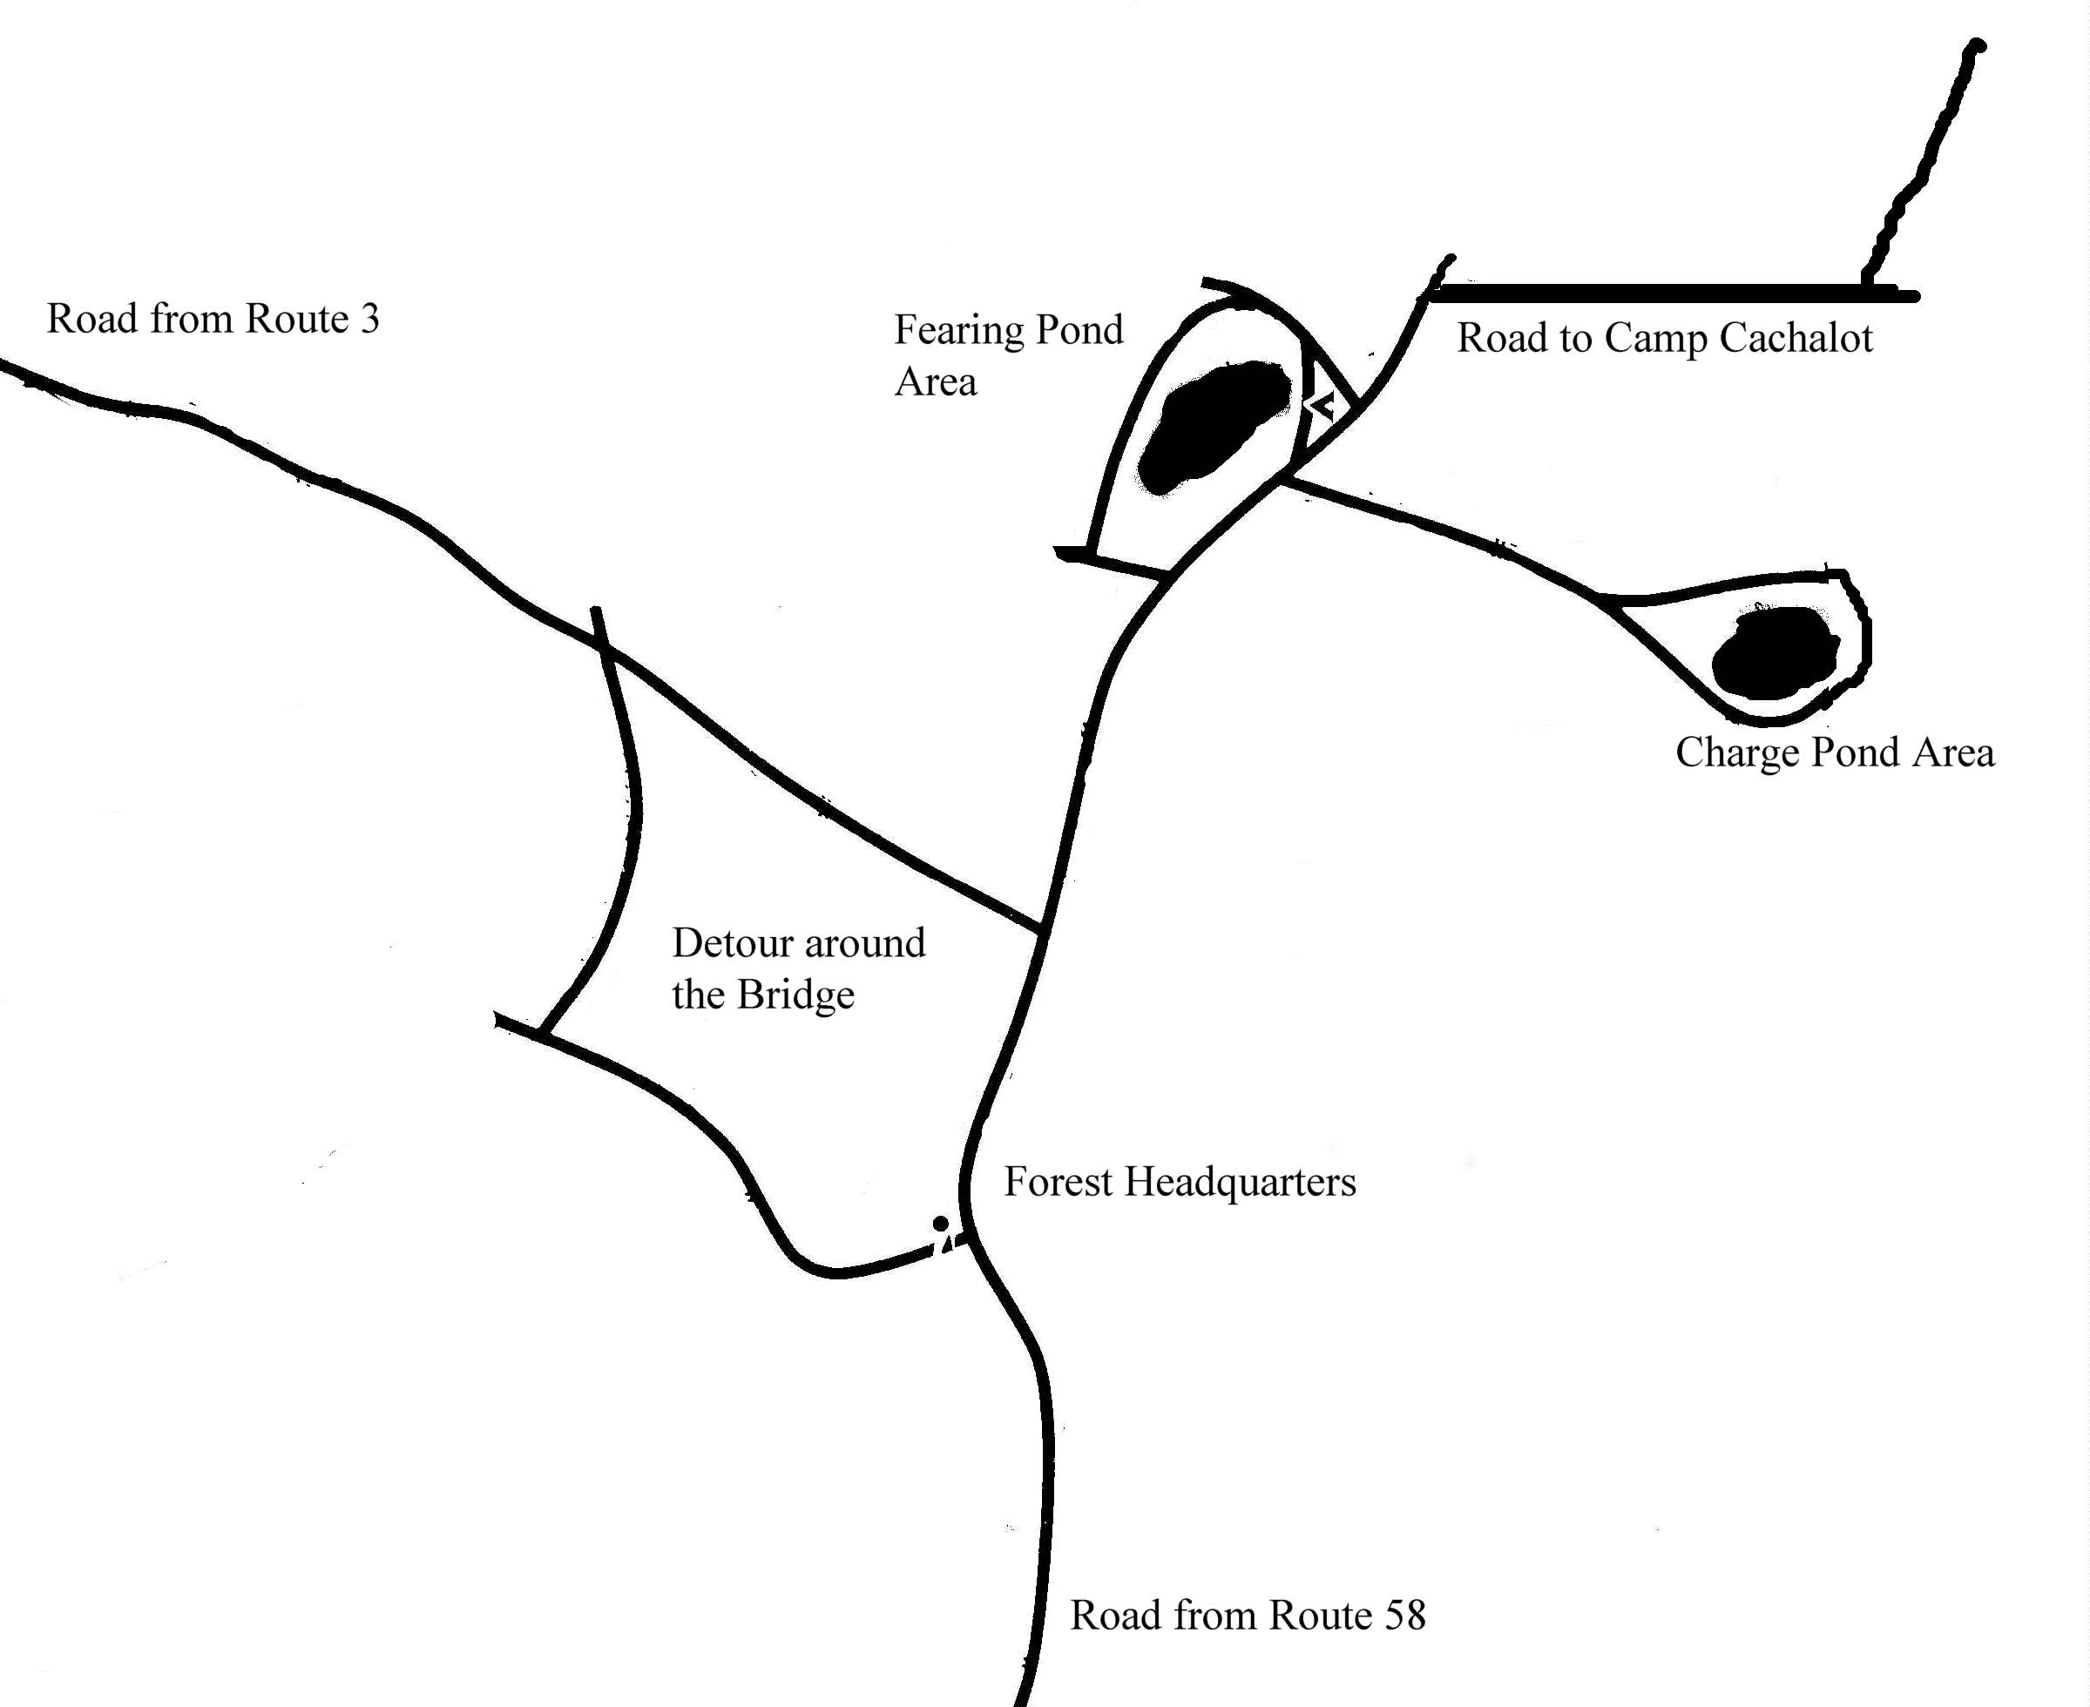

3. From the South, Cape & the Islands - Take 495 North. To Route 58-N. Travel North on Route 58 to South Carver, continuing straight ahead when Route 58 veers to the left. You will travel into the center of South Carver. After you leave South Carver, turn right onto Cranberry Road and continue into Myles Standish State Forest. When you reach Forest Headquarters you will encounter a detour because the bridge is out of service. Follow the detour signs that continue a circle around the bridge area and then follow the signs towards Fearing Pond and Camp Cachalot. The Road to Camp Cachalot is the next right after Charge Pond Road.
Bridge

Camp Cachalot
Myles Standish State Forest
Plymouth, MA 02360
508-295-2117

CAMP MAP
To Abner's
Dan Beard 6
James E. West 7
Cohackett 5S
Assonet 5N
Sconticut 3N
Namasket 3E
Winnetuxet 3W
Five Mile
Pond
Little Five Mile
Maintenance
Main Parking
Ranger
To Main
Gate
Baden Powell 8
21 Club
Boathouse
Camp Dir.
Duplex
Nurse
Pine Grove
Waterfront
Aquatics

Nature
Dining Hall
Chapel
Cooks
Cabin
Eagle
Quest
Rifle
Tom Cullen
Field
Council Ring
Boathouse
Field
Scoutcraft
Area
Trading
Post
Rear Gate
Cadre Staff Area
Agawam 2W
Sippican 2E
Acooshnet 1E
Mattapoisett 1W
Handicraft
Basketball Court
Winter
Cabins
Parade
Field
Troop Gear
Drop Off Point
Volleyball
Shotgun
Archery
Camp Cachalot
Narragansett Council

Camp
Office
Mountain Bikes

NORTH

Map of Camp Cachalot Legend
Latrine Camp Building Camp Field Waterfront Camp Road

Nurse Camp Site Area Sports Area Ponds Camp Path

CAMP EMERGENCY PROCEDURES

FIRE - Send to runners immediately to the camp office with the following information:
- The location of the fire,
- The type of fire,
- The severity of the fire,
- And what type of personal injury has occurred if any.

When the siren is sounded, all Scouts, leaders and visitors should report immediately to Tom Cullen Field across from the Trading Post and assemble by troop. Troops should then await further instructions from a staff member, a head count will be taken at this time. While walking to the field keep a watch for emergency vehicles that may be attempting to reach the fire. Stay off all camp roads after reaching the Field unless directed otherwise by a staff member.

LOST SWIMMER - The waterfront will be cleared immediately. Some adults may be requested to assist. At the sound of the camp siren, the LBD (Lost Bathers Drill), All Scouts, and unit leaders will report to Tom Cullen Field across from the Trading Post where a staff member will take attendance. The camp office will continue the LBD alarm until such time as the missing swimmer is located.

LOST CAMPER - The unit leader will report any suspected lost camper to the camp office. The camp staff will then initiate the appropriate search procedures.

EXTREME HEAT - In the case of extreme heat, the camp director will declare a heat alert and program activities will be adjusted accordingly. Unit leaders and Scouts are reminded to watch for symptoms of heat exhaustion and heatstroke. Watch especially for Scouts wearing inappropriate clothing and/or not taking adequate amounts of fluid.

LIGHTNING OR SEVERE STORMS - The waterfront will be cleared immediately. All watercraft will return to shore. Scouts will report to their campsites unless otherwise instructed by a staff member. Avoid open fields. Any other needed instructions will be issued by the camp office.

NATURAL DISASTER (Earthquake, Flood, Etc.) - In the event of a natural disaster all Scouts and adults should remain in the activity area they are in or go to the nearest campsite and await instructions from a staff member. If this is the area that is affected then all personnel should move to the nearest safe area and await instructions.

MAJOR ACCIDENTS OR DEATH - In the event of a major accident or death, the following staff personnel are to be notified by reporting the incident to the camp office by runners or phone: The Camp Director, the Program Director, and the Camp Medical Officer.

CHILD ABUSE - The Camp Director must be notified of any incidence of child abuse. The report must include as much supporting information as possible. The report is to be kept confidential. Tell only those who need to know. Above all, protect the dignity and privacy of the victim.

CHEMICAL SPILL - In the event of a chemical or hazardous waste spill, a person should be stationed to keep all campers or visitors away from the spill. By runner or by radio the office must be notified.

EXPRESS CHECK IN

This is the most important page to read in this book.

With up to 150 Scouts and leaders possibly checking in during any given week, we need your help. We want to make this the easiest, fastest and most efficient check in process you’ve ever experienced, but, the plain and simple truth is, we need your cooperation. We will have all the staff available in the parking lot and at various check-in points to assist wherever needed.

Express Check in will only work if your unit turns in their medical forms prior to your week.

We need you to:

- Have scouts arrive wearing bathing suits with towels easily accessible.

- Upon arriving at camp, a drop off area for Scout and Troop Gear will be marked with your troops campsite name along the road opposite the parking lot. Gear must be dropped off prior to your troops check in time so that it may be delivered to your site.

- Arrive at the Welcome Center tent at your pre-assigned troop check in time ready to depart – NOT SOONER – NOT LATER.

3. Arrive with your entire troop if at all possible. You will not be allowed to proceed without them.

4. The Camp Director and the staff in the parking lot will greet you.

5. Staff guides will be assigned to your troop. They will assist and lead your Scouts throughout the entire check in procedure and provide a packet of information related to your stay.

- Express Check In will only work if you have turned in your medical forms at the Tuesday night Leaders Meeting at Camp prior to attending camp. Be sure you have any late medical forms and medications in their original containers, marked with the scouts name along with you to be brought to the nurse at check in time. These should be in alphabetical order and ready to turn in at the Health Lodge.

- A camp vehicle will be provided to bring your gear to your campsite while your scouts are touring the program areas, signing up for merit badges, and taking the swim test.

- Move to the dining hall for your seating assignments and dining hall procedures. Remind the Scouts to pay attention because you will be here for 16 meals during your stay.

- Return to your campsite, change clothes for the evening meal (Scout Uniform) and finish campsite setup.

THANK YOU - YOUR COOPERATION IS WHAT MAKES THIS WORK!!!

DAILY PROGRAM SCHEDULE

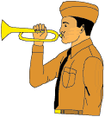
Time: Event:

7:00 AM Reveille
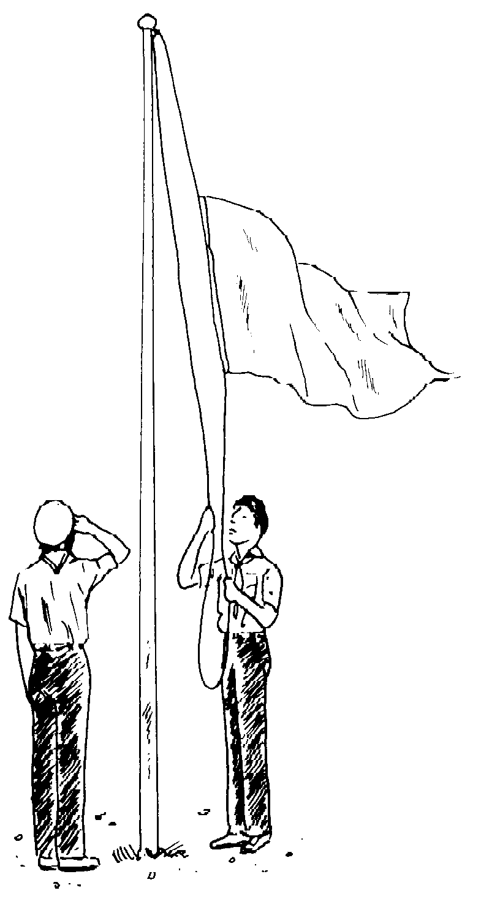
7:45 AM Waiters Report To Dining Hall
Camp Flag Raising Ceremony

8:00 AM Breakfast

9:00 – 12:00 AM Eagle Quest and Merit Badge Instruction

10:30 AM Scoutmasters' Second Cup of Coffee

12:00 PM Waiters Report To Dining Hall

12:15 PM Lunch

1:00 - 2:00 Siesta

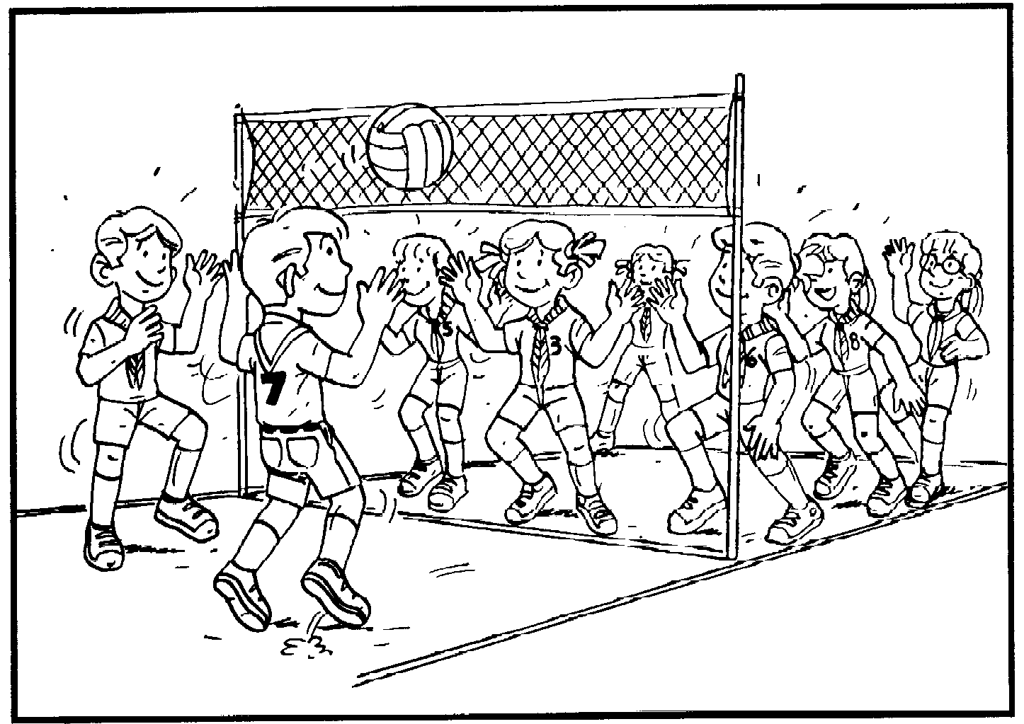
2:00 - 4:00 Eagle Quest And Merit Badge Instruction

4:00 - 4:30 Troop/Patrol Competitions
Make up work in the Areas as needed

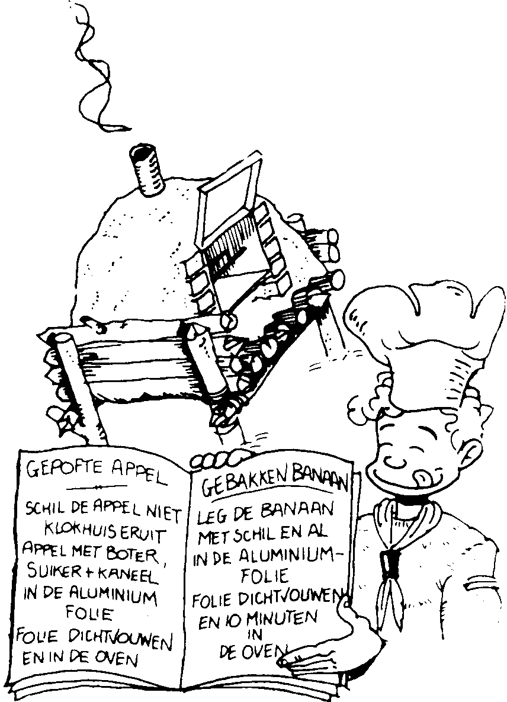
5:45 PM Waiters Report To Dining Hall
Flag Retreat Ceremony

6:00 PM Dinner

7:00 PM Campwide Activity (if applicable)

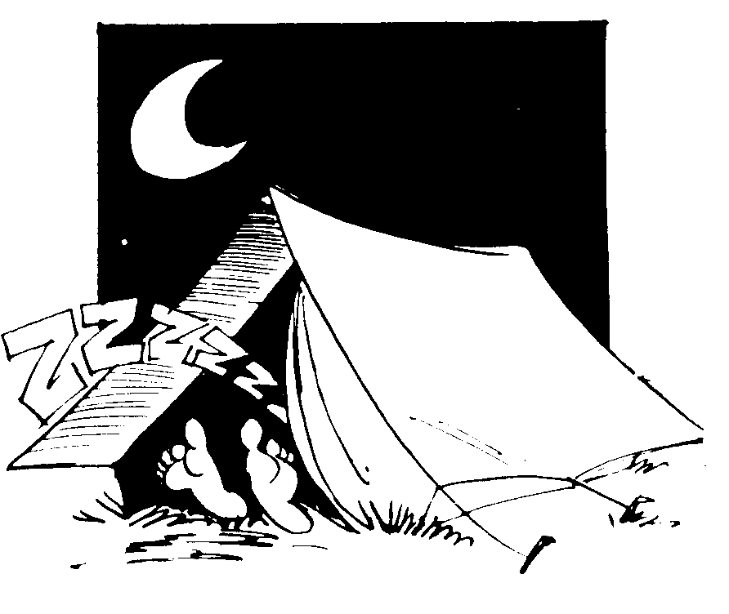
9:30 PM Taps / Lights Out / Quiet Time

OPERATIONAL TIMES

HEALTH LODGE
The health lodge is open one-half hour before and one-half hour after each meal, plus after evening events until 10:00 p.m. for issuing medication to campers. For any additional time needed for taking medication, individual arrangements can be made with the Health Officer.

In case of injury or sickness, the health lodge is open 24 hours a day. Please be sure to immediately report any injury or sickness no matter how minor it may seem at the time.

SITE PROVISIONs OUTFITTER
A staff member will be available after breakfast at the dining hall to issue equipment to troops. (Toilet paper, cleaning supplies, etc.) Any items, which need to be returned or picked up, should be done so at this time. Site Boxes will be available for sign out by the Scoutmaster upon arrival at the registration table.

TRADING POST
The camp Trading Post hours are similar to program area times with a few bonus hours throughout the week – just check the schedule outside the door for specific times. The store is supplied with BSA camping items, books, shirts and other Scout merchandise. It is also stocked with traditional beverages and snack items, personal hygiene and convenience store items. Plus, custom designed Narragansett Council, Anawan Council, and Cachalot Scout Reservation souvenirs will be available. A new assortment of items will be added this year.

FLAG CEREMONIES

➢ Every morning and evening the camp conducts a flag ceremony.
➢ Scouts will have the chance to be part of the color guard.
➢ Troops are encouraged to be at ceremonies in proper uniform.
- A flag pole is provided in each campsite for individual troop ceremonies

HEALTH AND REST

➢ Sleep can make or break a week.
➢ It is essential that everyone get the rest they need.
➢ Siesta is from 1:00 p.m. to 2:00 p.m. All Scouts should be in their site for H.B.T. (Horizontal Bunk Training)
➢ Please make sure “quiet time” is enforced between 9:30 p.m. and 7:00 a.m.

Noise travels very well at night – please respect your neighbors.

UNIFORMING

➢ There is only one Official Class A Uniform – Please wear it at all required times!
➢ Please be proud of your uniform and encourage the same from your Scouts.
➢ Everyone being in full Class A Uniform can have a huge impact on your troop’s performance, morale, identity and spirit.
➢ Please- won’t you at least try? (hat, shirt, socks, belt, short or trousers – that’s all…)
- Class “B” uniform- Scout shorts & Tee shirt- is encouraged for daily events unless otherwise specified.
- Troop or Scouting oriented Tee shirts are encouraged, Camp Tee Shirts are available at the Trading Post.

VISITORS

Parents and friends are always welcome at camp and we invite them to see the camp and what the Scouts have been doing throughout the week. Visitors must first check in at the Handicraft Building for security reasons. While visitors are welcome at any time, we suggest certain times over others as it coincides with camp activities that would allow visitors to see some special activities.

➢ Sunday or Friday night campfire programs
➢ Wednesday is Magee Day starting at 5:00 p.m. Visitors may tour camp, check out various areas and displays, as well as visit your campsite.
➢ All visitors should use the main parking lot and check in with the Camp Office.
- No vehicles are allowed in main camp or in the campsites.
- No pets are allowed in main camp or in campsites.
➢ Person with disabilities should notify the Camp Director preferably prior to their arrival.

There are no meals served in the dining hall on Wednesday evenings!
We’re having a cookout!


MAIL
Please have mail addressed in the following manner:
Scouts’ Name,
Troop Number and Campsite
Camp Cachalot B.S.A.
P.O. Box 637
South Carver, MA 02366

TELEPHONE

Camp Cachalot's phone number for incoming calls is 508-295-2117. Please keep in mind that this is primarily a business phone, for the use of the Camp Administration. Non-emergency messages will be taken from 1:00PM to 8:00PM and delivered to the Scout's Unit Leader at the next mealtime. Scouts are strongly discouraged from phone use, and must have a note from their Scoutmaster to place a call. Outgoing calls must be made collect or with a calling card. If someone needs to contact a camper in the event of an emergency, contact the camp office and a message will be given to the requested party immediately.

DINING HALL PROCEDURES

All dining hall tables are assigned to troops during the Sunday check in procedure. Each troop sends one waiter per table for each meal about 15 minutes prior to serving the food. Waiters will be responsible for setting out eating utensils, beverage cups, napkins and any other condiments that are needed for that particular meal. The Dining Hall Staff will assist Scouts in what they will be putting on the tables.

- At breakfast and dinner, troops will be dismissed to the dining hall from the camp flagpole area across from the dining hall after flag ceremony. All Scouts are expected to be at the flag ceremony.

- Scouts will then proceed to the side door of the dining hall and line up to wait for the dining hall steward to invite them into the dining hall. Feel free to join in with the singing while the staff sings camp songs.

- Adult Scouters are welcome to get a cup of coffee while you wait.

- Upon entering the dining hall, all Scouts and Scouters will remove their hats.

- Meals are served cafeteria style. As Troops are allowed to enter they will enter the serving lines where Scouts will be served their meal.

- Scouts may return to the serving line for seconds when announced.

- Scouts and leader are to remain in the dining hall until dismissal except for the noon meal. There are short programs after each meal. At noon meals, Scouts will be allowed to return to their site for siesta with the Scoutmasters permission, upon completion of their meal. Waiters remain to clean up.

- The Scout uniform is expected dress for the evening meal. (This means tucked in and buttoned up!)

- Waiters remain at the table until after dismissal for cleanup. The Dining Hall steward will assist the Scouts on when to bring items to the kitchen area and dirty dishes to the dish room. Adult supervision is sometimes helpful, especially for the younger Scouts and early in the week.

Cafeteria style serving is a very efficient way to serve meals. Food is always hot, there is less waste and can be served just as quickly (if done with Scout cooperation) as any other style service. Your cooperation, patience and understanding of this new procedure is greatly appreciated.

ASST. RANGER PROGRAM & HOME REPAIR MERIT BADGE

Want to be a part of improving camp's little breaks, leaks and burnout's? Then how about helping out with our Asst. Ranger Program or the Home Repairs Merit Badge. Our Ranger sure could use and extra hand around camp, and in the process you could help a scout to earn a merit badge - sounds like a fair trade to me. We are recommending this merit badge for those scouts13 years old or older due to the high use of various tools and equipment. If you think you would like to help a Scout and Camp let us know.

GOOD TURNS

A Scout is clean! Each day units are asked to clean up various areas of camp. We ask that your unit does its good turn during the day at your earliest convenience. In addition, units are assigned an area of camp to police and maintain for the week. This assigned area should be policed sometime during the day (Refer to the Camp Wide Good Turn sheet - Forms Manual). Both of these assignments will be reflected in the score of the daily inspection as applicable for each unit.

GUIDELINES FOR YOUTH PROTECTION

GUIDELINES FOR SCOUT CAMP:
Summer Camp is an important part of the Boy Scouts of America program. It is in the camp atmosphere and in the outdoor program that character building and the citizenship purposes of the Scouting program are best taught.
Members of the Boy Scouts of America come from all kinds of backgrounds, and they bring with them their experiences. In meeting your leadership responsibilities, you may be confronted with situations that are alien to your experience. You may be unsure as to how to resolve them. Child abuse is one such situation and regardless of your background you are responsible for the physical and emotional safety of the Scouts in your charge. Be a source of strength and help to the Scouts in your camp.

CHILD ABUSE
Child abuse is a crime against youth. Child abuse can involve mental, physical or sexual victimization of children. Most camp staff members and unit leaders are NOT trained to make judgments about whether a child has been a victim of any kind of abuse.
If you suspect that a child is a victim of child abuse, you must report it to the Camp Director. The Camp Director will then contact the Council Scout Executive who in turn will report the information to the Department of Social Services. Failure to report any knowledge of suspected child abuse may carry criminal action. All states do however provide immunity from prosecution for reporting suspected child abuse in good faith.

INITIATIONS AND HAZING
These do not belong in a Scout Camp! Scout Leaders are to ensure that all new campers are properly oriented and assisted to get the most out of their camping experience. Under the B.S.A. policy, these situations are regarded as child abuse, and will not be tolerated.

SCOUTING: A GAME WITH A PURPOSE

Scouts should be coming to Camp to have fun!!!!!!!!
Camp Cachalot encourages a balanced summer camp program. Although Scouts come to camp to get certain merit badges that are more difficult to get locally, there is a great need for them to enjoy the fun events and challenges around camp. Surveys show that if a Scout thinks summer camp is only a place to go to get merit badges and not to enjoy the outdoor programs with there troop and other scouts then they are missing out on some of the best times of their lives.

We are working to encourage more troop activities where Scout troops can build up the needed unity that makes the troop stronger by encouraging relationships as well. Our theme is Team Cachalot because we try to build our staff and your troop into a team that works together to promote scouting skills, advancement and leadership. To accomplish this we have built into our program a large number of individual and troop fun activities. Be sure to sign up your troop for unit activities or encourage your Scouts to do activities on their own, but take time out to have fun at camp this year.

We have plenty of fun events like rifle shooting, shotgun, archery, swimming, canoe trips, mountain bikes, nature adventures, and fishing. We have scheduled pick-up games in basketball, softball, volleyball, kickball, horseshoes, etc. We have Scoutcraft games and an obstacle course along with many fun events in our Handicraft Area. And don't forget our competitions and camp wide game that you can take part in.

We offer something to do for fun for everyone. So don't be left out this year! So be sure to take advantage of our afternoon and evening activities.

AFTERNOON EVENTS

SPECIAL EVENTS
Each of the program areas throughout camp will be offering special events to challenge and excite Scouts and leaders. Activities will be scheduled at different times during the week. Promotional announcement and posters at camp will let you know when and what will be happening. Some activities will be for individuals while other will be for teams. Each area will have their own special programs.

HIKING TRAILS
Trails are available throughout Camp Cachalot. See our Nature or Field Sports Directors for information.

CACHALOT TOTEM TRAIL
The return of this special program encourages the younger Scouts of your troop to participate in activities from all of the areas at camp. Scouts will go from area to area to have their card signed for doing special events in those areas. After participating in enough events, the Scouts can purchase a patch segment at the trading post.

EVENING EVENTS
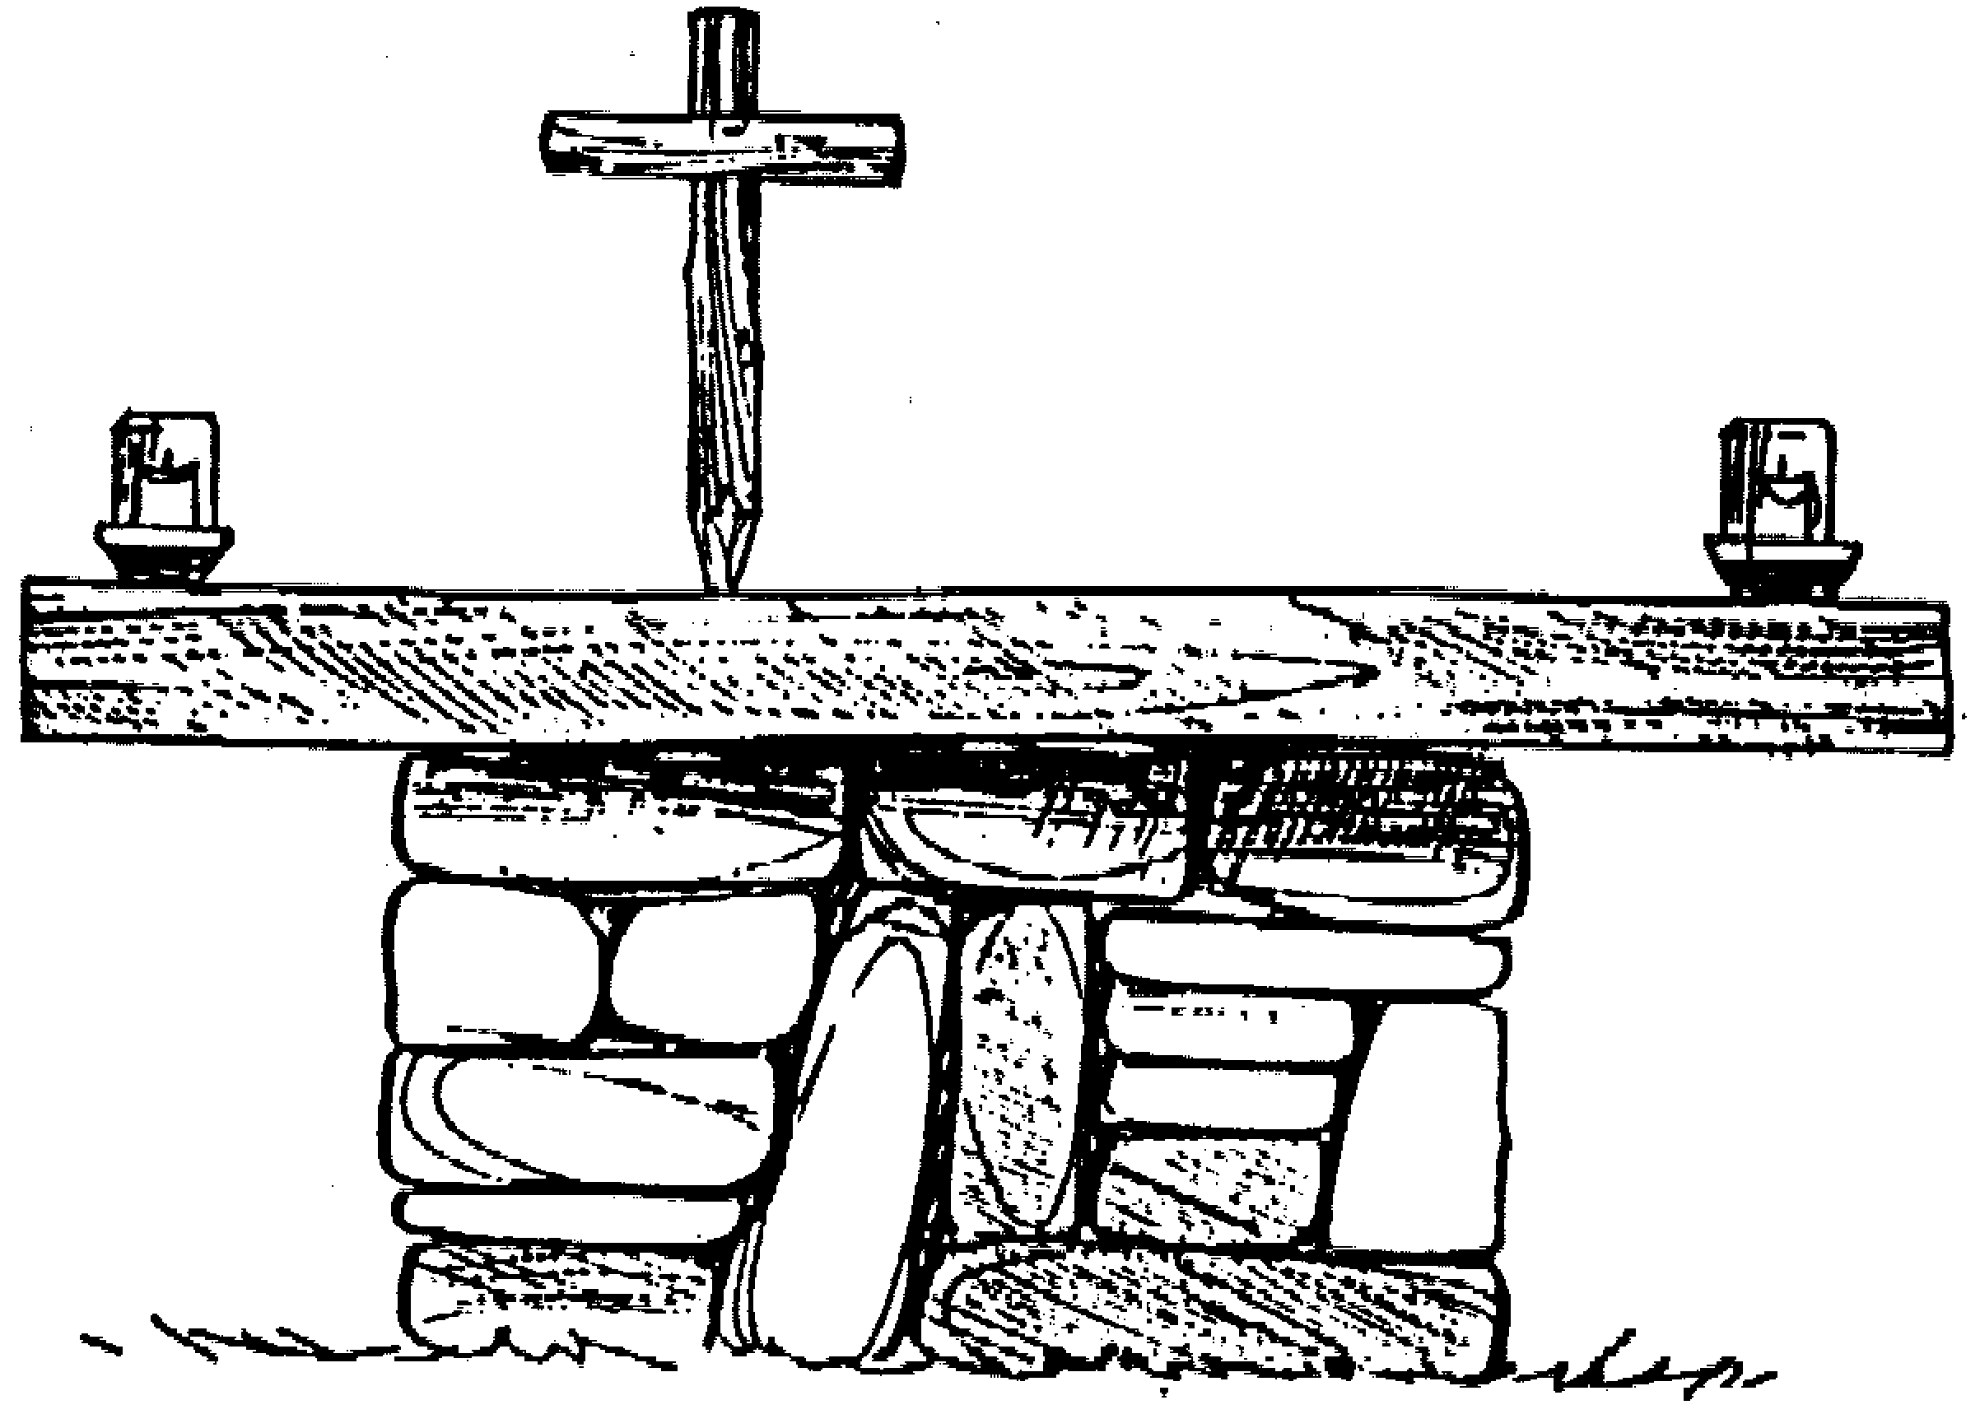

SUNDAY

CATHOLIC Mass
Mass will be offered at the Camp’s Chapel at 5:15PM. All areas close at 5:00PM so Scouts, Leaders and Staff may attend. A SCOUT IS REVERENT

FAMILY BAR-B-QUE
Camp Cachalot invites visitors and family members to stay for a family bar-b-que. Leaders are asked to see the form and make arrangements for your visitors and family members to stay for the meal and then possibly stay for the campfire.

KICK-OFF CAMPFIRE
After dinner in our unique dining atmosphere, your troop is invited to attend our opening campfire. It always seem to get camp off on the right foot with a wild selection of songs, skits and special announcements by our entertaining staff.

MONDAY

GREAT CACHALOT COOKOFF & FIRESIDE CHAT
In the past this Leader Competition was exciting and rewarding (especially for the judges). It still will be, the way has been paved for any type of culinary masterpiece! Cobblers, cakes, casseroles, soups and stews, all will be accepted (with the exception of the Manny Special, Sugar Omelets.) Try and keep your cost down to about $10.00, let’s not go overboard! Remember the Scoutcraft area has a limited supply of Dutch Ovens and the dinning hall will have some basic ingredients, but the serious chef might bring his or her own special equipment and secret ingredients.

TUESDAY
SPORTS NIGHT UNDER THE LIGHTS UNTIL 9:00 PM
Organized sports events such as Kickball, Volleyball, Ultimate Frisbee, and Soccer will be held in Tom Cullen Field. These events will be held depending on enough interest and all are welcome to participate.

SAFE SWIM DEFENSE & SAFETY AFLOAT CERTIFICATION
Certification is good for two years, so check your cards. These certifications are required for troops who do year round aquatic activities.


WEDNESDAY

MAGEE DAY ACTIVITES
The George Magee Foundation has made possible many of the facilities found at camp, as well as other camps throughout New England. To honor the memory of his generous spirit, we celebrate Magee Day with special activities. This is a chance for your parents and guests to see all of the cool things you’ve been doing for the week. The Camp-wide game and the Cookout are the activities dedicated to the Memory of George Magee.

Camp-wide Game
Game will start at 5:15PM see your game form for specific details. The Game will be held in Tom Cullen Field.

Camp-wide Cookout
We will have a camp-wide cookout on Wednesday evening and family members are invited to join their sons at this meal. Tickets must be purchased or ordered in advance of this event by calling the camp office or coming to the Camp Trading Post by the Monday before. This will be served at 6:00PM after the Game.

SENIOR PATROL LEADER/SCOUTMASTER CANOE RACE
This competition puts the best against the best. This is where the Scoutmasters get to show the SPL what they know, or is it the other way around? This event will start at 7:00PM after the Cookout.

THE GREAT CACHALOT SAILING REGATTA
This is your chance to show off your sailing skills and to compete in this fun event. This event will start at 7:00PM after the Cookout.

THE CANOE SWAMPING CHALLENGE
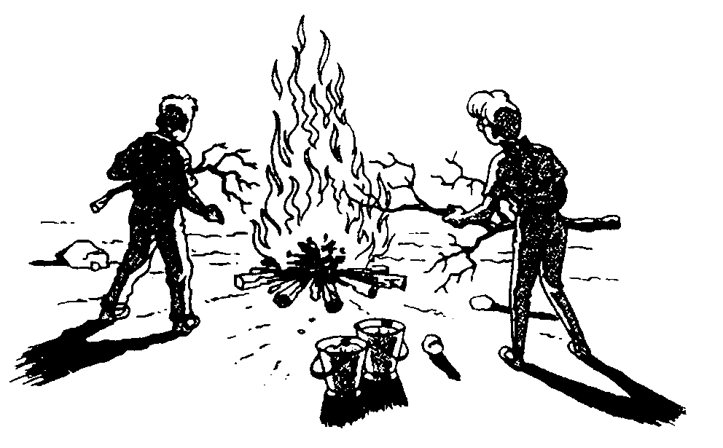
Do canoes really sink? They do when someone is throwing buckets of water into it. It is a fun event the winner is the crew that is the driest. As much fun to watch as it is to participate.

THURSDAY
LUAUS
Fire on the water, contests and competitions, music and food, and FUN.

FRIDAY
CLOSING CAMPFIRE
After such a fantastic week, it seems right to have a closing campfire to recap the week, recognize some outstanding Scouters, and prepare to say so long to Cachalot for another season.

THE ORDER OF THE ARROW TAP OUT CEREMONY
Continues to be an important part of our campfire program. As in past Arrowmen are encouraged to wear their sashes to this event and dinner.

EVENING PROGRAM SCHEDULE

Time: Event: Place:
SUNDAY
5:15PM Catholic Mass Camp Chapel
6:00PM Family Bar-B-Que Prescott Dinning Hall
7:00PM Aquatics Safety Demo Waterfront
8:00PM Kick-Off Campfire Council Ring

MONDAY
7:00PM Great Cachalot Cook-Off Scoutcraft
Open Shooting All Ranges
Open Boating Waterfront
CPR Aquatics Requirement Prescott Dinning Hall

TUESDAY
7:00PM Open Boating Waterfront
Next Weeks Scoutmasters Prescott Dinning Hall
Safe Swim/Safety Afloat Waterfront

WEDNESDAY
5:00PM Flag Retreat Ceremony William Joyce Flag Pole
5:15PM Camp Wide Game Tom Cullen Field
6:00PM Cookout The Pine Grove
7:00PM SPL/SM Canoe Race Waterfront
Cachalot Sailing Regatta Waterfront
Canoe Swamping Waterfront

THURSDAY
6:00PM Wilderness Survival Overnight 6:00PM-6:00AM
7:00PM Ecumenical Service Camp Chapel
7:30PM Open Shooting All Ranges
Luaus Waterfront

FRIDAY

8:00PM Closing Campfire & OA Tap Out Council Ring

ADVANCEMENT PLANNING

 First year Scouts are encouraged to take Eagle Quest rank advancement.

Second Year Scouts not yet First Class may want to sign up for both meritbadges and Eagle Quest rank advancement.

All Scouts should be made aware of any prerequisites for Merit Badges and Pre-Camp preparation items.

Leaders should make sure that the Scouts have chosen programs acording to their interest and ability.

All Scouts taking any requirement in Eagle Quest should sign up by rank, on the forms supplied in the leader’s packets, so they can be turned in on Sunday evening.

Please help Scouts plan their time effciently, but also remind them to allow themselves time to relax and enjoy camp.

Program Suggestions for your Scouts

First Year Second Year Third Year Four or More Years

Eagle Quest
Rank
Advancement

Finish Up
Eagle Quest
Rank
Advancements
Work On
Leadership,
Merit Badges,
Projects for
Star, Life and
Eagle
Ca.P.S. Program

Outpost Camping

BSA Lifeguard
Totin’ Chip
Firem’n Chit

Maybe
1 or 2 simple
Merit Badges
General
Merit Badges
With Intermediate Difficulty
Snorkeling General
Merit Badges With
Higher Difficulty
Mile Swim

Merit Badges of Interest

Older Boy Programs
For Example:
Fishing
Mammal Study
Leatherwork
Basketry
Art
Metalwork
For Example:
Swimming
First Aid
Cooking
Camping
Forestry
For Example:
Environmental Science,
Reptile Study,
Canoeing, Lifesaving, Sailing

For Example:

Shotgun Astronomy
Pioneering
Athletics

COUNSELOR IN TRAINING (C.I.T.)

CIT Corps.

What is the Cachalot CIT Corps? It’s the training program for 14-year-old Scouts who are serious about becoming future staff members. As a CIT, you will perform many of the same duties assigned to Staff members. You will participate in Campfires, ceremonies, cleaning details, some instructing responsibilities, and many other duties along side veteran staff members. During the day, you will train in various program areas and then spend the other half working towards personal advancement in the form of merit badges, specialty programs like BSA Lifeguard and Ca.P.S, as well as performing service hours to the camp. A CIT must be at least First Class rank or above, have his Scoutmaster and Parents’ permission, and have a positive Scouting attitude.

Interested in the Corps? The cost for the summer is $70.00 for the first week and $35.00 for each week thereafter. While it may seem strange to pay for a program where it appears you will be working all day. The Camp’s supervision wants to assure you that the CIT Corps is a dynamic training program which will challenge Scouts and expand there knowledge of Camp, Scouting, and themselves.

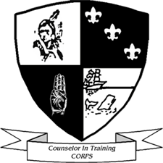
Please contact the Camp or Program Director if you want further information on this exciting program.

2002 EAGLE QUEST

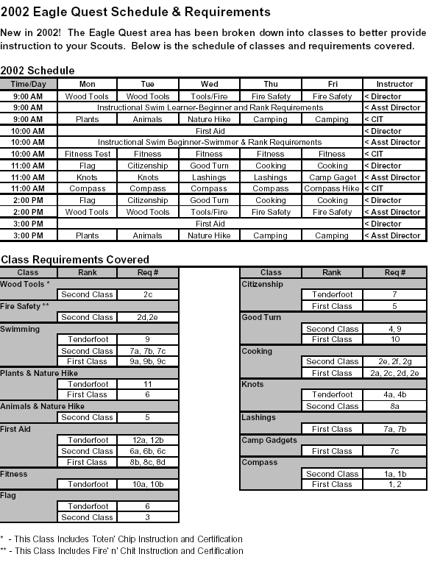
As you already know, some of the requirements for Tenderfoot, Second and First Class ranks have been changed and these new changes have been incorporated into the Eagle Quest Program.

MERIT BADGE MIDWAY

What is the Merit Badge Midway? New for 2002, the Merit Badge Midway is a unique area that will open up even more merit badges to your Scouts. How? Simple, we ask you the Scout Leaders along with the Merit Badge counselors in your Troop to offer classes during the day or evening. The camp will provide any needed materials and supplies whenever possible. We’ll also provide you with an area near the Commissioner’s shack to teach your classes. Do you have special equipment you need stored? We’ll provide a secure location for you to safely store your paraphernalia and supplies, anything that will make teaching your badge easier.

The concept of the Merit Badge Midway was the brainchild of former staff member Jason “Manny” Oliveria. Originally, Manny wanted to call the area “Mannyland”. While the name has changed the concept certainly hasn’t. His vision was of an area where older Scouts, who were bored of the same old program, could come in contact with Merit Badge Counselors who taught a multitude of badges. Often Scouts are interested in a badge, but they don’t have a counselor available in their area. Here, Scouts have an opportunity to meet knowledgeable counselors, while counselors can teach their favorite skills, hobbies, and interests with eager and enthusiastic Scouts.


If you or any adult member of your Troop would like to teach a class at the Midway, please let us know before the Tuesday night Scoutmaster’s meeting a week prior to your arrival at camp. If you have any special requests, please let us know then. This gives us time to put together a schedule for everyone at camp to enjoy. Please help us, help the Scouts of our Council and make “Mannyland” a success. The following are the merit badges that are not regularly offered at camp.

- AGRIBUSINESS
ANIMAL SCIENCE, FARM MECHANICS, PLANT SCIENCE
- ARTS AND CRAFTS
BUGLING, MUSIC, THEATER
- BUSINESS AND INDUSTRY
AMERICAN BUSINESS, ENTREPRENEURSHIP, PULP AND PAPER, SALESMANSHIP, TEXTILE
- CONSERVATION
- HOBBIES
BACKPACKING, COIN COLLECTING, COLLECTIONS, DOG CARE, GARDENING, MODEL DESIGN AND BUILDING, PETS, RADIO, STAMP COLLECTING
- NATURAL SCIENCE
ARCHAEOLOGY, BIRD STUDY, GEOLOGY, INSECT STUDY, OCEANOGRAPHY
- COMMUNICATIONS
CINEMATOGRAPHY, JOURNALISM, PHOTOGRAPHY
- PERSONAL DEVELOPMENT
AMERICAN CULTURES, AMERICAN HERITAGE, CITIZENSHIP IN THE COMMUNITY, CITIZENSHIP IN THE NATION, CITIZENSHIP IN THE WORLD, COMMUNICATIONS, DISABILITIES AWARENESS,

FAMILY LIFE, GENEALOGY, PERSONAL MANAGEMENT, PUBLIC SPEAKING, READING, SCHOLARSHIP, TRAFFIC SAFETY
- PHYSICAL SCIENCE
ATOMIC ENERGY, CHEMISTRY, COMPUTERS, ELECTRICITY, ELECTRONICS, ENERGY, SPACE EXPLORATION
- PROFESSIONS
ARCHITECTURE, DENTISTRY, ENGINEERING, LANDSCAPE ARCHITECTURE, LAW, MEDICINE, SURVEYING, VETERINARY MEDICINE
- PUBLIC SERVICE
CRIME PREVENTION, FIRE SAFETY, PUBLIC HEALTH, SAFETY
- SPORTS
CLIMBING, FLY FISHING, GOLF, HORSEMANSHIP, MOTORBOATING, SKATING, SNOW SPORTS, WATERSKIING, WHITEWATER
- TRADES
AMERICAN LABOR, AUTO MECHANICS, DRAFTING, GRAPHIC ARTS, PAINTING, PLUMBING, WOODWORK
- TRANSPORTATION
AVIATION, RAILROADING, TRUCK TRANSPORTATION


AQUATICS

Camp Cachalot maintains a staffed waterfront for instructional and recreational Aquatic activities. Everything from BSA Lifeguard to Water Polo is available. Scouts are tested and placed in ability groups on SUNDAY.

All Swimmers MUST have a completed health form.

FREE SWIM:
Just for the fun of it. Troop swims are scheduled and all campers are encouraged to participate. Also available to Troops, materials to set up their own Safe Swim Areas for the free swim using the Safe Swim Defense Plan.

MILE SWIM CERTIFICATE:
Scouts who are good swimmers may choose to qualify for the mile swim certificate. See waterfront schedule for times.

BSA LIFEGUARD CERTIFICATION:
This is a vigorous program consisting of swimming and lifesaving instruction and practice. This will require a full week of aquatic instruction and work. This is a good program for older campers. CPR certification is required and not offered at camp. Adults are welcome.
Note: All waterfront badges must be completed before you work on this Certification.

SAFE SWIM DEFENSE:
Required of all troops at Cachalot. All leaders should participate in this training. A certificate is awarded upon successful completion of this training. This training is a must if troops wish to set up their own swim areas at camp or during camping trips year round. The certification is good for two years.

SAFETY AFLOAT:
This is a training program promoting boating, boating safety and also to set standards for safe swim activities in watercraft. A certificate is awarded upon successful completion of this training. This training is a must if troops wish to set up Boating Trips while at camp or during camping trips year round. The certification is good for two years.

POLAR BEAR SWIM:
For years campers have tried to see the Cachalot Polar Bear. They just don’t get up early enough and honestly just make to much noise. The Cachalot Polar Bear is really rather shy. If you would like to try your luck then come down bring a leader and some friends. But remember to be quiet. Schedule this event with the Aquatics Director.

CANOE OVERNIGHTER:
Plans for this event should be made with several people and the proper forms made out. Two forms must be filled out 24 hours prior to leaving. (This program will be fun if proper planning is done in advance.)
See: Waterfront Director for canoes, instruction and requirements.
Program Director for plans – “Trip Registration Form”.
Dinning Hall/Camp Director for food – “Trip Meal Request Form”.

Five Mile Pond is a happening pond, and offers one of the best Aquatics Programs around.

*Swimming MB, Lifesaving MB & Ca.P.S. Candidates
MUST have LONG PANTS and a LONG SLEEVE BUTTON UP SHIRT.
BSA GUARD will be offered from 9:00 to 12:00, when staffing needs allow, with extra Guard hours required. Must have all Waterfront MB's.
2002 AQUATICS PROGRAM CHART

STARTS | CLASS NAME | PRE-REQUISITES | REMARKS
    9:00 AM | SWIMMING MB | BE A SWIMMER BY TUESDAY | LIMITED READING NO WRITTEN WORK
 | SAILING MB | BE A SWIMMER HAVE SWIMMING MB | 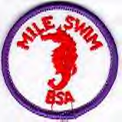  1 HOUR CLASS WRITTEN WORK PRACTICE AS NEEDED DURING TROOP SWIM
 | CANOEING MB | BE A SWIMMER HAVE SWIMMING MB | POSSIBLE WRITTEN WORK PRACTICE AS NEEDED
 | MILE SWIM CERT. | BE A SWIMMER HAVE SWIMMING MB | CLASS WORK AND DISCUSSION
 | BSA LIFEGUARD | BE A SWIMMER HAVE ALL AQUATICS MB CPR CERTIFICATION | CLASS 9:00-12:00 AND 2:00-4:00
 | Ca.P.S. | BE A SWIMMER HAVE SWIMMING MB
    10:00 AM | SWIMMING MB | BE A SWIMMER BY TUESDAY | LIMITED READING NO WRITTEN WORK
 | CANOEING MB | BE A SWIMMER HAVE SWIMMING MB | 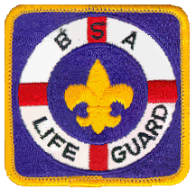  POSSIBLE WRITTEN WORK PRACTICE AS NEEDED
 | ROWING MB | BE A SWIMMER | NO WRITTEN PRACTICE AS NEEDED
 | LIFESAVING MB | BE A SWIMMER HAVE SWIMMING MB | LIMITED READING NO WRITTEN WORK
 | BSA LIFEGUARD CONT. | BE A SWIMMER HAVE ALL AQUATICS MB CPR CERTIFICATION | CLASS 9:00-12:00 AND 2:00-4:00
  11:00 AM | SWIMMING MB | BE A SWIMMER BY TUESDAY | LIMITED READING NO WRITTEN WORK
 | SAILING MB | BE A SWIMMER HAVE SWIMMING MB |   1 HOUR CLASS WRITTEN WORK PRACTICE AS NEEDED DURING TROOP SWIM
 | LIFESAVING MB CONT. | BE A SWIMMER HAVE SWIMMING MB | LIMITED READING NO WRITTEN WORK
 | SNORKELING CERT. | BE A SWIMMER HAVE SWIMMING MB | FUN BADGE TO EARN
 | BSA LIFEGUARD CONT. | BE A SWIMMER HAVE ALL AQUATICS MB CPR CERTIFICATION | CLASS 9:00-12:00 AND 2:00-4:00
2:00 PM | UNIT FREE SWIM |  | SCHEDULED TROOPS
3:00 PM | UNIT FREE SWIMS |  | SCHEDULED TROOPS
7:00 PM | OPEN BOATING |  | UNTIL SUNSET UNLESS OTHER WISE SPECIFIED
7:00 PM | WATER GAMES & CHALLENGES |  | UNTIL SUNSET UNLESS OTHER WISE SPECIFIED

THE ECOLOGY CONSERVATION AREA



The Ecology Conservation Area (Nature) is located at the old pump house near Five Mile Pond. Scouts will be sure to observe all nature has to offer at Camp Cachalot. The Nature Area will open for extra activities and help in the evening from 7:00PM to 8:00PM except on Wednesdays (Magee Day).

SPECIAL NOTES: Requirements #4 & 5 of Nature Merit Badge (raising tadpoles, fish, mollusks or plants) needs to be completed before attending camp. Scouts should also bring a note from their Scoutmaster and be able to discuss their activities (failure to do so will result in a partial being given). Requirement #8 of Reptile Study Merit Badge (maintaining one or more reptiles or amphibians for at least a month) must be done at home. Bring a signed note from the Scoutmaster that this requirement has been completed.

NATURE HIKES:
The Nature Area offers a variety of hikes, which are designed to be fun as well as to help Scouts understand a little about nature. These hikes may be done on an individual basis or as a group, such as a patrol activity.

BOTANY HIKES:
A botany hike focuses on plants that live in New England. Edible, useful and poisonous plants are identified. Botany hikes are short and are a good way to see Camp Cachalot. Check with the area director for a time for these hikes.

STARGAZING:
Stargazing sessions begin after dark and the time will be announced at the Nature Area. These sessions usually last an hour but sometimes there is so much to observe…. they just can’t stop! Participants need a signed permission slip from their Scoutmaster to attend.

FISHING:
FISHING IS NOT ALLOWED AT OR NEAR THE SWIMMING AND/OR BOATING AREAS. HOOKS NEED TO BE ON A SWIVEL SO THEY CAN BE REMOVED WHEN DONE FISHING. WADING IS NOT ALLOWED.
There are fishing demonstrations where basic skills are taught (Camp Cachalot practices a “Catch & Release” policy). You need to register at the Nature Area. First session begins on Monday and will be held as interest warrants from 7:00PM to 8:00PM. After that, find a favorite spot on Five-Mile Pond and try your luck.

CACHALOT FISHING DERBY:
Each week a certificate will be presented to the camper who catches the largest fish. Have your catch weighed at the Nature Area.


2002 ECOLOGY CONSERVATION PROGRAM CHART

STARTS | CLASS NAME | PRE-REQUISITES | REMARKS
  9:00 AM | SOIL & WATER MB |  | WRITTEN WORK REQUIRED
 | MAMMALS MB |  | GOOD FOR NEW SCOUTS
 | Ca.P.S. |  | THURSDAY
10:00 AM | NATURE MB | REQ. # 4, 5 |   CONSIDERABLE READING
10:00 AM | ENVIRONMENTAL SCIENCE MB |  | DIFFICULT BADGE EARLY AM & PM WORK
10:00 AM | FISHING MB |  | MEETS EVERYDAY
  11:00 AM | FORESTRY MB | REQ. # 5 | GOOD FOR 2ND YEAR CAMPER
 | MAMMALS MB |  | GOOD FOR NEW SCOUTS
 | FISH & WILDLIFE MANAGEMENT MB | REQ. # 5, 7 |   CONSIDERABLE READING AND WRITTEN WORK
  2:00 PM | REPTILE STUDY MB | REQ. # 8 | FOR OLDER SCOUTS
 | ENVIRONMENTAL SCIENCE MB |  | DIFFICULT BADGE EARLY AM & PM WORK
 | FORESTRY MB | REQ. # 5 | GOOD FOR 2ND YEAR CAMPER
  3:00 PM | WEATHER MB |  |   READING AND SOME WRITTEN WORK
 | MAMMALS MB |  | GOOD FOR NEW SCOUTS
 | SOIL & WATER MB |  | WRITTEN WORK REQUIRED
4:00 PM | MAKE UP TIME |  | EXTRA HELP
7:00 PM | ASTRONOMY MB |  | A VERY DIFFICULT BADGE





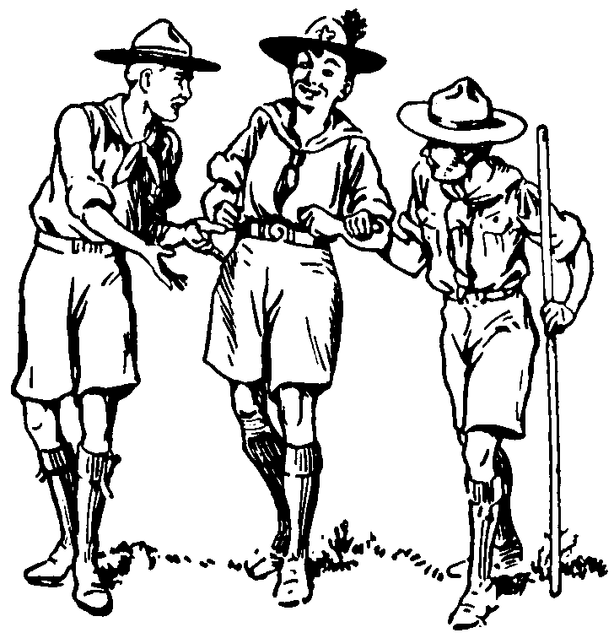

HANDICRAFT

CRAFT PROJECTS: In addition to the Merit Badge program, this area offers the opportunity to work on a variety of craft oriented projects. The Trading Post will offer a variety of crafts and projects that may be purchased and completed in the handicraft area.

TROOP PLAQUE: We encourage your unit or patrols to work on a plaque to hang in the dining hall during that week. Try to have the date and everyone’s name on it. You may put it on the fireplace mantel when you have finished it and members of the staff will hang it up for you. Plaques must meet the new size requirements, if you are unsure, please see the Handicraft Director for the sizes.

SPECIAL PROJECTS: Evening classes will focus on various specialty areas of art. Check with the
Handicraft Director for the special events for your week.

There is always something to do in the Handicraft Area. If you have free time, contact the Handicraft director to see if there is something you can work on.

Paints, brushes, paper, and other tools are available for you and your Scouts to use for projects that they would like to do during the week. Please see the Handicraft Director for the availability and cost of supplies.

This is a great area to spend time in, whether it be an hour in the morning or afternoon, a place to go when you’re feeling creative and want some guidance, or if you just want to have fun with different types of art.

Highly visited, and highly popular with young and old Scouts alike, Handicraft is back with a solid set of merit badges for the creative Scout. There are some costs involved, but usually a maximum of $5.00 (except for Photography, which is more). With ten fantastic merit badges and cool area events, make sure to stop by the Handicraft Area during your stay at Cachalot.

Certain Merit Badges require you to purchase or bring your own materials. In order to make the learning experience the same for each Scout, certain merit badges will require Scouts to work on the same materials so that instruction will be the same. This should enhance the program for each merit badge. See the manual or handicraft director for materials needed or there cost.

2002 HANDICRAFT PROGRAM CHART



STARTS | CLASS NAME | PRE-REQUISITES | REMARKS
9:00 AM | METALWORK MB |  | GOOD FOR NEW SCOUTS
9:00 AM | LEATHERWORK MB |  | GOOD FOR NEW SCOUTS
9:00 AM | Ca.P.S. |  | DAY TO BE ANNOUNCED
  10:00 AM | WOODCARVING MB | TOTIN' CHIP & BUY KITS |   APPROX. $5.00 FOR 2 KITS
 | BASKETRY MB | NEED TO BUY BASKET KIT AT TRADING POST | GOOD FOR NEW SCOUTS
 | SCULPTURE MB
  11:00 AM | ART MB |  | GOOD FOR NEW SCOUTS
 | WOODCARVING MB | TOTIN' CHIP & BUY KITS |   APPROX. $5.00 FOR 2 KITS
 | POTTERY MB | NEED TO BUY CLAY
  2:00 PM | LEATHERWORK MB |  | GOOD FOR NEW SCOUTS
 | BASKETRY MB | NEED TO BUY BASKET KIT AT TRADING POST |   GOOD FOR NEW SCOUTS
 | METALWORK MB |  | GOOD FOR NEW SCOUTS
3:00 PM | ART MB |  | GOOD FOR NEW SCOUTS
3:00 PM | FINGERPRINTING MB |  | GOOD FOR NEW SCOUTS
3:00 PM | POTTERY MB | NEED TO BUY CLAY
4:00 PM | MAKE UP TIME |  | 1/2 HOUR EXTRA HELP
    7:00 PM | HANDICRAFT DEMOS
BY. APPT | PHOTOGRAPHY MB | MUST SUPPLY OWN CAMERA AND FILM | APPROX. $15.00 FOR FILM DEVELOPING
BY. APPT | INDIAN LORE MB |  | LOCATION TBA

SCOUTCRAFT



So you want to be an all around great Scout? Then our Scoutcraft program is your answer for success. This area offers all the badges and plenty of crazy events to turn you into a Scouting Skills Machine. We’ve got fire building, Dutch Oven Cooking, Paul Bunyan Award, Totin’ Chip, Firem’N Chit, great structures to build, and much, much more! There is definitely new life in this old Scouting favorite.

FIRE BUILDING: Everything You need to know about fire building.

STOVE USE: This demo will show how to properly use a Peak I, Coleman and Solid Fuel stoves.

UTENSILLESS &
TINFOIL COOKING: The “No Clean Up” way to cook. Schedule at dinnertime for a great meal out.

DUTCH OVEN COOKING:
Add new dishes to your menu, including fancy desserts and breads.

ROPE WORK:
Knots, splicing, and basic lashings are all taught here, a must for any Scout or Scouter.

BASIC SKILLS INSTRUCTION:
Offered in the Eagle Quest Program.

PAUL BUNYAN:
This award practices the learning of safe axemanship. Application for this award can be obtained in the Scoutcraft Area.

COOKING DEMO:
These cooking demonstrations are for Scouts and Scouters who enjoy new ways of cooking, including new main meals and desserts. Stop by and do some taste testing.

STRUSTURE BUILDING:
Use of poles, knots and lashings to make camp gadgets, towers, bridges and gateways.
2002 SCOUTCRAFT PROGRAM CHART

STARTS | CLASS NAME | PRE-REQUISITES | REMARKS
  9:00 AM | PIONEERING MB (1) |  |   PROFICIENT IN KNOTS & LASHINGS, SPLICING & ROPE MAKING, SOME WRITTEN WORK
 | CAMPING MB | REQ. # 8, 20 NIGHTS OF OUTDOOR CAMPING | CONSIDERABLE WRITTEN WORK
 | Ca.P.S. |  | TUESDAY
    10:00 AM | WILDERNESS SURVIVAL MB |  |   BUILD & SLEEP IN A SHELTER, COOK AND EAT EDIBLE PLANTS
 | HIKING MB (1) | REQ. # 6 | REQ. # 5 CAN ONLY BE PARTIALLY COMPLETED AT CAMP
 | PIONEERING MB (2) |  | PROFICIENT IN KNOTS & LASHINGS, SPLICING & ROPE MAKING, SOME WRITTEN WORK
11:00 AM | HIKING MB (2) | REQ. # 6 |   REQ. # 5 CAN ONLY BE PARTIALLY COMPLETED AT CAMP
11:00 AM | COOKING MB |  | CONSIDERABLE WORK MUST COOK 9 MEALS AT THE SITE
11:00 AM | PAUL BUNYAN CERT | TOTIN' CHIP | ADVANCED SKILLS IN AXE & WOODS TOOL USE
  2:00 PM | CAMPING MB | REQ. # 8, 20 NIGHTS OF OUTDOOR CAMPING | CONSIDERABLE WRITTEN WORK
 | COOKING MB |  | CONSIDERABLE WORK MUST COOK 9 MEALS AT THE SITE
3:00 PM | WILDERNESS SURVIVAL MB |  | BUILD & SLEEP IN A SHELTER, COOK AND EAT EDIBLE PLANTS
3:00 PM | ORIENTEERING | REQ. # 7 | FUN WITH MAP AND COMPASS
3:00 PM | PAUL BUNYAN CERT | TOTIN' CHIP | ADVANCED SKILLS IN AXE & WOODS TOOL USE
4:00 PM | MAKE UP TIME |  | EXTRA HELP
7:00 PM | SCOUTCRAFT DEMOS |  | DEMOS ON COOKING, CAMPCRAFT & OTHER FUN STUFF

FIELD SPORTS

When taking badges in the Shooting Sports section of Field Sports, we strongly recommend Scouts be at least 13 years old, (14 for shotgun) simply because the merit badges are difficult and take a lot of patience and practice. However, everyone is welcome to the area.

NOTE: ORIENTATION WILL BE REQUIRED OF ALL SCOUTS AND SCOUTERS PRIOR TO USING ANY OF THE SHOOTING RANGES.

The Ranges will be open on selected nights from 7:00PM to 8:00PM for extra shooting or instruction help.

RIFLE RANGE:
Merit Badge and NRA Awards. Scouts have an opportunity to use .22 caliber rifles on our 10 bay rifle range with Troop Shoots and working on the Rifle Shooting Merit Badge. Campers will also be able to work toward NRA Marksmanship Awards.

SHOTGUN RANGE:
Merit Badge Program recommended for older Scouts (age 14 & older). We use 12 & 20 gauge shotguns on our mini trap range during Troop Shoots and Shotgun Shooting Merit Badge.

BLACK POWDER:
A program for older Scouts (age 14 & older) using Black Powder Rifles to fire 50 caliber lead balls will be available, as long as conditions permit. This will involve special instruction with the emphasis on safety, as the roar of muskets can be heard throughout the entire camp.

ARCHERY:
Archery Merit Badge and Troop Shoots are offered so that everyone will have the opportunity for instruction with standard target arrows and bows with 20 to 30 pound draws. For older campers, the Camp Cachalot Archery Range offers the use of compound bows. You must be 14 years old to use the compound bows.

FIELD SPORTS:
Kickball, softball, volleyball, soccer, flag football and many other sports can be played at Tom Cullen Field, located across from the Trading Post. Inter-Troop Challenges are encouraged. “Pickup Games” are also scheduled throughout the week. Not only are they fun, but they are also a great way to get to know Scouts from other troops and councils.

HORSE SHOES:
Individual, patrol or troop competition is available at our Horse Shoe Yard. Try your luck and challenge another troop for the Horse Shoes Championship of the Week.
2002 FIELDSPORTS PROGRAM CHART

STARTS | CLASS NAME | PRE-REQUISITES | REMARKS
    00 AM | RIFLE SHOOTING MB |  | DIFFICULT - 2 HOUR BADGE, MAY NEED EXTRA TIME FOR PRACTICE
 | SHOTGUN SHOOTING MB | $15.00 ADDED COST |   DIFFICULT - 2 HOUR BADGE, MAY NEED EXTRA TIME FOR PRACTICE
 | ARCHERY MB | PURCHASE SUPPLIES TO MAKE ARROWS AT THE TRADING POST | DIFFICULT - 2 HOUR BADGE, MAY NEED EXTRA TIME FOR PRACTICE
 | CYCLING MB
 | SPORTS MB | REQ. #2, 3, 4 | SOME WRITTEN WORK
  10:00 AM | RIFLE SHOOTING MB |  | DIFFICULT - 2 HOUR BADGE, MAY NEED EXTRA TIME FOR PRACTICE
 | SHOTGUN SHOOTING MB |  | DIFFICULT - 2 HOUR BADGE, MAY NEED EXTRA TIME FOR PRACTICE
 | ARCHERY MB |  |   DIFFICULT - 2 HOUR BADGE, MAY NEED EXTRA TIME FOR PRACTICE
 | CYCLING MB
 | PERSONAL FITNESS MB | REQ. # 1, 5, 7 | PHYSICALLY DEMANDING
11:00 AM | UNIT ACTIVITIES |  | AS SCHEDULED
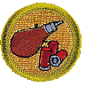  2:00 PM | UNIT ACTIVITIES |  | AS SCHEDULED
 | ATHLETICS MB |  | GOOD FOR A 2ND YEAR SCOUT
3:00 PM | PERSONAL FITNESS MB | REQ. # 1, 5, 7 | PHYSICALLY DEMANDING
3:00 PM | UNIT ACTIVITIES |  | AS SCHEDULED
7:00 PM | OPEN SHOOTING ALL RANGES |  |   OPEN TO ALL UNLESS OTHERWISE SPECIFIED
ALL DAY | SCHEDULED "PICK-UP" SPORTS GAMES |  | DESIRE TO HAVE FUN


AFTERNOON GAMES




NOTE!! The 4 O'clock hour is now set aside especially for games, competitions and inter-troop or patrol fun. See our schedule for what we're playing and then see our Field Sports director to sign up! You may even want to suggest some new games for us.

Summer camp is not only for earning merit badges and advancement, it is also a time for fun, and creating a better "Team" out of your troop. Both fun and teamwork, along with advancement, are an important part of a troop program.

With this in mind, we have done away with the 4:00 PM merit badge session to allow for scheduled troop and patrol wide games and events. (You will notice that no merit badges have been deleted from the schedule, but they are being offered at different times.)

On any afternoon you will find available to your troop or patrol; volleyball, basketball, soccer, or softball, obstacle course competitions, patch trade-o-rees, and much more.

Below is a schedule to use for your planning. Sign up with our Field Sports Director for the
activity that you and your fellow scouts want! See if you can try them all.

Monday | Tuesday | Wednesday | Thursday | Friday
Volleyball | Volleyball | Volleyball | Volleyball | Volleyball
Soccer | Softball* | Soccer | Softball* | Soccer
Basketball |  | Basketball | Basketball
 | Horse Shoes | Leader Horse Shoe Competition | Patch Trade-o-ree | Horse Shoes
Relay races~ |  | Relay Races~
 | Obstacle Course |  |  | Obstacle Course competiton

* Bring your glove! ~ Potato Sack, 3 Legged, Crabwalk, Sprinting, and many more!

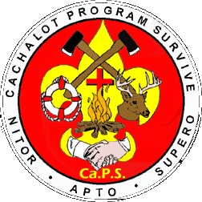CACHALOT PROGRAM SURVIVE (Ca.P.S)

Ca.P.S. was designed for the older boys in camp, who are looking for that certain something fun to do. It was designed to challenge the older boys. It focuses on the survival skills taught in many different program areas of camp. It was designed to take those skills and tie them together in one program, a survival skills program. The hope is to show the boys how to use all the skills in a practical manner. The boys will spend the week reviewing skills, then participate in a final event to test and tie it all together.

What areas in camp are involved in Ca.P.S.? What will they do in that area?
- Aquatics: Personal and group survival skills in and around the water
- Nature: Wild edible plants, drinking water, tracking, identification of poisonous plants and animals
- Scoutcraft: Fire building, and wilderness survival skills, survival kits
- Handicraft: Creating tools and utensils
- Program staff: Team work
- Health Officer: Wilderness first aid

 | STARTS | PRE-REQUISITES | AREA
Monday | 9:00 AM |  | PROGRAM
Monday | 1:00 PM | WILDERNESS SURVIVAL MB | SCOUTCRAFT
Tuesday | 9:00 AM | WILDERNESS SURVIVAL MB | SCOUTCRAFT
Tuesday | 1:00 PM |  | FIRST AID
Wednesday | 9:00 AM | SWIMMING MB | AQUATICS
Wednesday | 1:00 PM | SWIMMING MB | AQUATICS
Thursday | 9:00 AM |  | NATURE
Thursday | 1:00 PM |  | NATURE
Friday | 9:00 AM |  | HANDICRAFT
Friday | 1:00 PM |  | HANDICRAFT
Friday | 9:00 PM | M-F CLASSES | AQUATICS



HEALTH LODGE

The Health Officer will be offering the First Aid Merit Badge and the Emergency Preparedness Merit Badge. These will be offered barring any unforeseen emergencies.

STARTS | CLASS NAME | PRE-REQUISITES | REMARKS
9:00 AM
  10:00 AM | FIRST AID MB | FIRST AID REQ. FOR RANKS COMPLETED |   EAGLE REQUIRED
11:00 AM | EMERGENCY PREPAREDNESS MB | FIRST AID MB | OPTIONAL EAGLE REQUIRED FOR LIFESAVING MB
7:00 PM | CPR |  | FOR AQUATICS BADGES MONDAY

SCUBA DIVING CERTIFICATION SPECIALTY CAMP

This year we are offering a Scuba Certification course during week 5. This program will be limited to 12 participants and must have at least 6 people signed up by June 3rd to begin. This course can be taken on a daily basis or as a camper. The cost of this program will be $200. Look for more information to follow on this course. You can contact the Scout Office or the Camp Director for more information.

MOUTAIN BIKE PROGRAM

Camp Cachalot runs a mountain bike program for campers. We suggest that you plan a time of riding within camp, on the State trails or an out of camp bike hike. Bicycle rides can be planned as a patrol or troop event with the assistance of a leader. Our Mountain bike director will be more than happy to assist you in your planning. We do not allow individual trips.
Camp Cachalot is located in Myles Standish State Forest, which has 125 miles of bicycle trails. Troops are encouraged to sign up for a troop or patrol bike hike. A bicycle trip could be planned for one day during your camp stay. Scouts and leaders may make arrangements to bring their bicycles and helmets to camp with them, but due to lack of secure storage, the camp cannot be held responsible for theft or damage to your bikes and equipment. All bikes must be stored in the mountain bike garage with the camp bikes, but remember this is sometimes unlocked and bike locks should be considered. Leaders and Scouts are encouraged to use the camp's equipment for this reason
Bikes cannot be used in the main camp areas. You may want to call ahead to check availability and reserve some the week before you arrive. Please advise us of the days you will be out of camp for these trips.

ADULT LEADERS

ADULT LEADER'S AREA
The Adult Leader’s meeting area and lounge is the old shower house, located at the turn in the road by the waterfront. The area will be open if the construction is completed in time. The project is being done by volunteer leaders and will take time. If not completed an area will be set up so that leader’s may converse with other leader’s, complete paperwork, or simply sit and relax. The coffee pot in the dinning hall is always on. The daily Second Cup of Coffee will be held at the dinning hall at 10:30AM every morning.

NO SMOKING POLICY
This policy is in effect in the lounge as well as all other buildings, program areas and areas where Scouts congregate as a group. Smoking if done at all, should be done in the privacy of other adults away from the main camp area and other Scouts. Thank you for your cooperation and understanding on this matter.

ADULT LEADER EVENTS

Adult Leader Events are a part of Camp Cachalot. These events are purely for fun, but should be a great way to meet other adults and establish lasting friendships. Events MAY include: a Horseshoe tournament, the Leaders Cookoff, Staff/Leader Shooting Competition, Leaders Merit Badge and the Scoutmaster/SPL canoe race. These events and more will be explained more during the daily adult leaders meeting.

Leaders Merit Badge
This is a great way to assist the camp staff and the scouts in camp. Sign up for this Merit Badge, complete the requirements, and earn a special recognition patch. The requirements will include five areas of service to the camp. Take a merit badge class with the boys (your choice), do a service project, assist on the waterfront at least once, participate in a Leaders event, and attend all leaders meetings.

SECOND CUP OF COFFEE

We don’t want to spend too much time in meetings when we can be out doing our jobs for real. Hopefully you have the same philosophy. However, we also realize that the meetings are an important way to get info to you and receive feedback in return. Usually each gathering will evaluate the past day’s events and be a source for conveying information about the next 24 hours of activity. Each gathering will start at 10:30 am each day and be held at the Dinning Hall Coffee Area out back under the carport.

FIRESIDE CHAT

What a great resource of knowledge we have with all the leaders! Keeping our goals in mind of helping individual units with their year-round program, we will be holding a Fireside Chat during the Leader's Cookoff Competition on Monday night. This is open to all leaders and you are welcome even if you are not competing. This will be very informal time where you can sit with a cup of coffee and tell others about what works for your troop. We ask that you bring any information including flyers, info sheets, booklets, pictures etc. with you to camp that you can share or give to other leaders.

Some topics we thought troops might be interested in sharing ideas about are:
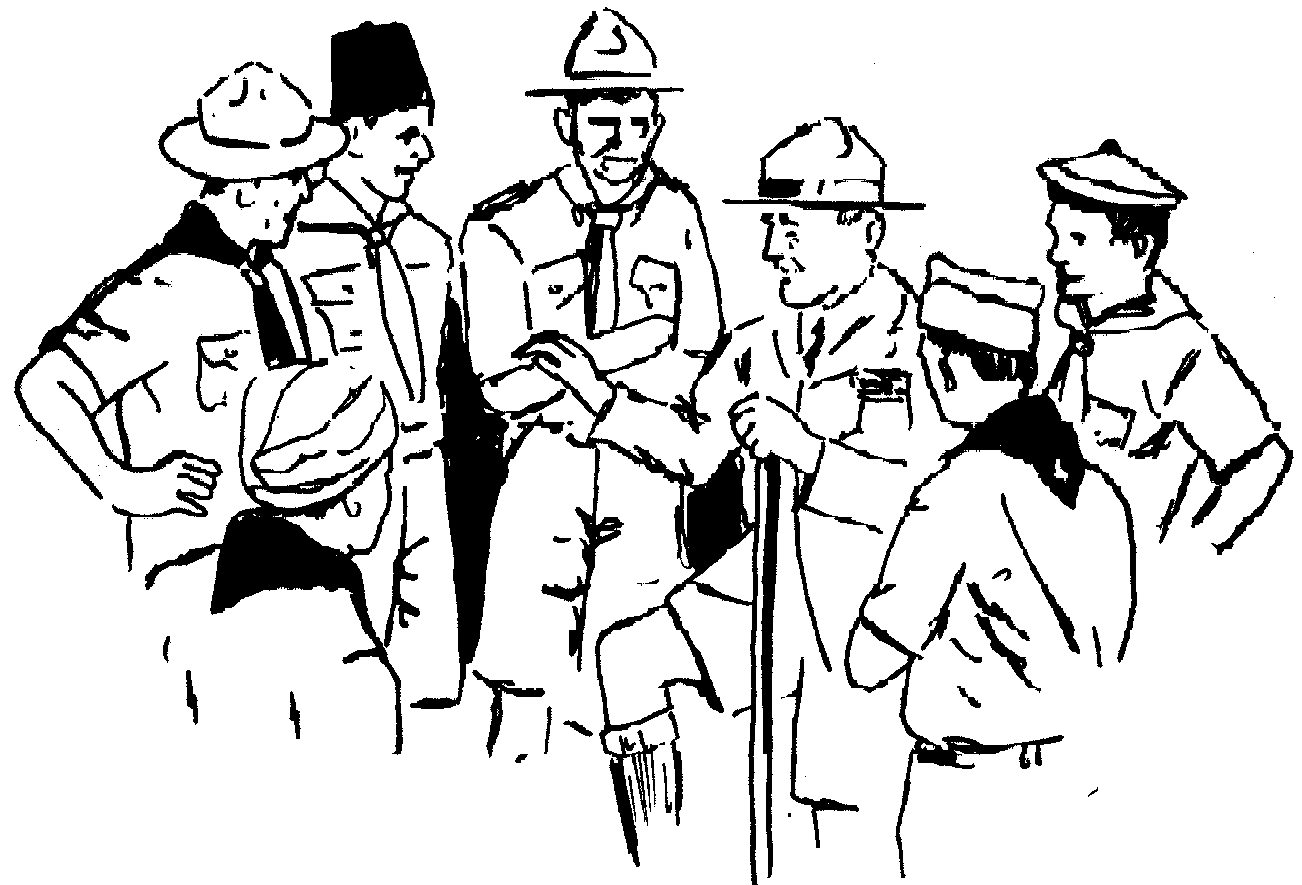
➢ Different places you go camping
➢ Ideas for troop meetings
➢ How to recruit new Scouts
➢ How to have effective Webelos Crossovers
➢ Leader recruitment
➢ Youth training methods
➢ Other topics limited only by your imagination.

VEHICLES IN CAMP

Personal vehicles in camp must be parked in the camp parking lot, which is located near the Maintenance Building. Only vehicles provided with passes will be allowed beyond the parking lot.

HOW CAN YOU HELP?

We know that many of you have wonderful skills and knowledge in various aspects of camp. We want you to know that we always welcome your assistance to make camp better. We ask that you let us know of any special skills that you have that would add an extra dimension to the week.

Some possible areas that come to mind include:

Eagle Quest, all leaders are encouraged to spend some time assisting younger scouts with advancement.
Merit Badge Counselors who would like to assist us or offer a badge while at camp.
Ecology/Conservation/Forestry areas
Song and Skit Leading, willing to assist our staff and troops with song and skit ideas
Medical (Nurse, Doctor, EMT)
NRA Range Master
Waterfront Aid / Lifeguard willing to assist on the waterfront
Hobbyists & Collectors willing to share their knowledge.
School teachers who have the summer off and are willing to assist the camp or be on staff.
Assistant Rangers - we always need people to assist us with camp maintenance needs, if you have a trade or the time before, during the season, or during your week at camp please contact us.
Contact the Program Director or leave your name and number at the Council service center with your information.

CAMPSITE INSPECTIONS

A daily inspection of each unit's campsite will be conducted by one of our Camp Commissioners. One of their roles is to inspect and check the campsites. This will allow them to also see that your site is good condition and that you have the items that you need. This should be considered a positive part of your camping program. Leaders can use this to demonstrate proper procedures and cleanliness to their Scouts. This time is also a time to get to know your Commissioner. Our Camp Commissioner is there to meet your needs and to make your stay a pleasant one. He will always be available to answer your questions and to assist you in any way. For more information on Campsite Inspections see the form in your Leaders Form Manual.

FIELD TRIPS

As a troop highlight, you may wish to take a trip to a historic around our camp. Plymouth, Cape Cod and the Boston area are near and a troop committee can plan trips for a day out of camp event.

DEPARTURE

Cachalot Check Out Procedures:

1. Clean and sweep all tents
2. Sweep floors in latrine.
3. Scrub and clean urinal, toilet seats, and washbasin with bleach. (Be sure to wear rubber gloves.)
4. Wash and rinse off picnic tables.
5. Return program box to Trading Post.
6. Leave a complimentary woodpile for the next troop.
7. Pick up all litter along the road and trail as you walk from your campsite.
8. Return all equipment borrowed from the Camp Outfitter.
9. Return all Scoutmaster and SPL evaluation forms to the camp office.
10. Be sure that site inspection with staff member is completed.
11. Clear troop account.
12. Check for troop mail
13. Make sure you’re signed up for next year**

** Troops can reserve a site for 2003 by filling out the site reservation form and submitting to the Camp Director along with a $50.00 site fee. (Your deposit from this year will be deductible from your 2002 fee.) Troops will be awarded their site preference on a first come – first served basis with priority going to troops holding a particular site during this summer camp.

TIME | Nature | Field Sports | Scoutcraft | Handicraft | Aquatics | Eagle Quest | Health Lodge
9:00 AM | Soil and Water | Rifle Shooting | Pioneering (Part 1) | Metal work | Sailing | Instructional Swim Learner-Beginner
9:00 AM | Mammals | Shotgun Shooting | Camping | Leatherwork | Swimming | Instructional Swim Learner-Beginner
9:00 AM | Ca.P.S. (Thursday) | Archery | Ca.P.S. (Tuesday) | Ca.P.S. (Friday) | Canoeing | Wood Tools &  Fire Safety
9:00 AM |  | Sports |  |  | Mile Swim | Wood Tools &  Fire Safety
9:00 AM |  | Cycling |  |  | BSA Lifeguard | Nature & Camping
9:00 AM |  |  |  |  | Ca.P.S. (Wednesday)
10:00 AM | Nature | Rifle Shooting | Hiking (Part 1) | Woodcarving | Canoeing | First Aid | First Aid
10:00 AM | Environmental Science | Shotgun Shooting | Pioneering (Part 2) | Basketry | Rowing | Instructional Swim Beginner -Swimmer | First Aid
10:00 AM | Fishing | Archery | Wilderness Survival | Sculpture | Swimming | Fitness | First Aid
10:00 AM |  | Cycling |  |  | Lifesaving (Part 1) |  | First Aid
10:00 AM |  | Personal Fitness |  |  | BSA Lifeguard |  | First Aid
11:00 AM | Forestry | Unit Activities | Hiking (Part 2) | Art | Swimming | Scout Skills &  Cooking | Emergency Preparedness
11:00 AM | Fish & Wildlife Mgmt |  | Cooking | Woodcarving | Sailing | Scout Skills &  Cooking | Emergency Preparedness
11:00 AM | Mammals |  | Paul Bunyan | Pottery | Lifesaving (Part 2) | Rope Work | Emergency Preparedness
11:00 AM |  |  |  |  | Snorkeling Cert | Compass | Emergency Preparedness
11:00 AM |  |  |  |  | BSA Lifeguard |  | Emergency Preparedness
1:00 PM | Ca.P.S. (Thursday) |  | Ca.P.S. (Monday) | Ca.P.S. (Friday) | Ca.P.S. (Wednesday) |  | Ca.P.S. (Tuesday)
2:00 PM | Reptile Study | Athletics | Cooking | Leatherwork | Unit Swim | Wood Tools &  Fire Safety
2:00 PM | Environmental Science | Unit Activities | Camping | Basketry | Unit Swim | Scout Skills &  Cooking
2:00 PM | Forestry |  |  | Metal work | Unit Swim
3:00 PM | Weather | Personal Fitness | Wilderness Survival | Art | Unit Swim | First Aid
3:00 PM | Mammals | Unit Activities | Orienteering | Fingerprinting | BSA Lifeguard | Nature & Camping
3:00 PM | Soil and Water |  | Paul Bunyan | Pottery | Mile Swim
4:00 PM | Extra Help  Make Up Time | Extra Help  Make Up Time | Extra Help  Make Up Time | Extra Help  Make Up Time | Extra Help  Make Up Time | Extra Help  Make Up Time
7:00 PM | Astronomy | Open Shooting | Scoutcraft Demos | Handicraft Demos | Open Boating | Area Closed | CPR Class for Aquatics Badges  (Monday)
 |  |  |  |  | (selected days) | Area Closed | CPR Class for Aquatics Badges  (Monday)
 |  |  |  |  | Water games | Area Closed | CPR Class for Aquatics Badges  (Monday)
OTHER | Nature Scavenger Hunt | Sports Games | Great Cachalot Cookoff | Art Contests | Thursday Night | The Totem Trail
 |  |  |  |  | Water games | The Totem Trail
 |  |  |  |  | & Luaus | The Totem Trail

SCHEDULE

PARENTS APPENDIX

WHAT TO BRING TO CAMP

After 50+ years of camping experience, we've learned your stay is much more enjoyable when you bring:

Complete Scout Uniform Swimming Merit Badge Clothes (long sleeved
Hiking Shoes & Sneakers cotton shirt with collar, jeans with belt)
Extra shirts, shorts, socks, jeans, underwear, Canteen or water bottle
enough for 1 to 2 changes per day. Backpack
Sweatshirt, Jacket, Hat(s) A few trash bags
Sweat suit or pajamas Flashlight & extra batteries
Raincoat or Poncho Scout Handbook
Swimsuits (2 pair=1 to dry +1 to wear) Spending Money
Towels / washcloths Merit Badge Book (Books are also available
Toiletries (toothbrush, toothpaste, soap, for sale in the Trading Post)
shampoo, comb, .. a Scout is clean. Pre-Camp merit badge requirements
Handkerchiefs Money for certain Merit Badge requirements
Sleeping Bag or 3 warm blankets and sheet. Lockable Foot Locker or Plastic Trunk w/lock
Pillow Note mark all belongings with Scouts full
Notebook, pen & pencils name and Troop #
O/A Sash if Order of the Arrow Member

Some Nifty Extras
Mosquito netting Sun Glasses
Bible Camera/Film
Watch Sunscreen
First Aid Kit Sewing Kit
Insect Repellent (Crème or pump no aerosols!) Compass
Pocket Knife

WHAT NOT TO BRING TO CAMP

Aerosol cans of any type ………….. They can explode in fires, can cause eye injuries
Bow, arrows, ammunition ………… The camp will provide these when needed, See Shooting Director.
Sheath knives …………………….. Not approved for Scout Camps
Any other weapon ………………… Guns, handguns should not be in camp. See Shooting Director.
Fireworks of any kind …………….. Fire safety hazard, illegal in Massachusetts
Illegal Drugs, tobacco products, alcohol, or prescription drugs in improperly/unmarked containers
Double bit axes …………………… We supply the Scouts woods tools in scoutcraft.
Traps ……………………………. It is illegal to trap.
Televisions, boom boxes ………….. Walkman are permitted if okay with Scoutmaster, but discouraged
Anything of real or sentimental value - Valuable items should be left home.

* It is our recommendation that Scouts bring a lockable trunk to camp with a lock.

POCKET MONEY AND OTHER COSTS AT CAMP

It is recommended that a Scout bring pocket money to camp to use for merit badge or program materials and for purchases at the Trading Post. A Scout should consult with his Unit Leaders to determine what materials are needed for selected merit badges and how much money will be needed. Refer to the appropriate merit badge books or as your Unit Leader for advice.

Extra Costs: In addition to the cash you'll spend in our cool Trading Post, these are some other costs you may need to note:

Archery MB $1.50-$3.00 Woodcarving MB $5.00
Basketry MB $4.00-$6.00 Troop Photo . $7.00
Leatherworking MB $3.00-$5.00 Tickets for extra ammunition for troop
Metalwork MB $3.00-$5.00 shoots in shotgun & rifle can be purchased
Shotgun MB $15.00 at the Trading Post
Photography MB $10.00-$15.00, *plus providing 10 shots for .22= 25 cents
your own camera 1 shot shotgun for 25 cents

LOST AND FOUND

A lost and found will be maintained in the Camp Office. Please check through it on your way out of camp and reclaim your Scout's Treasures. We can not be responsible for items that are lost or stolen.

PHOTOGRAPHS

A photo of your Scout's troop is a great souvenir of camp! These color 8" x 10" troop photos will be taken on Monday after breakfast. Please see your Unit Leader for ordering details. Photos will cost $7.00 each

RELIGIOUS SERVICES

ROMAN CATHOLIC
On Sundays at 5:15 PM, before the Bar-B-Que supper there will be a Roman Catholic Service for those wishing to attend. This will be held in the Chapel behind the Cook's Cabin. All camp activities will begin after this service is completed. You are also welcome to use the Chapel for services, to pray as a unit or an individual.

2002 EAGLE QUEST
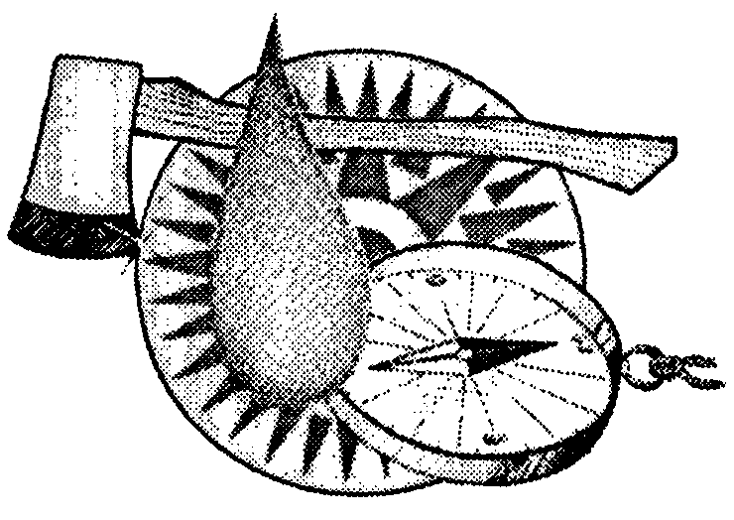
The Eagle Quest program is back for 2002! Eagle Quest was a new program for 1998, and was very successful for your younger scouts. The Eagle Quest program director and his assistants will work directly with your scouts. This particular program is designed to provide activities for the first time resident camper. These activities have been developed to teach skills related to rank advancement from Tenderfoot to First Class. The program is flexible and can fit into any Troop or campers summer camp schedule. The program IS NOT intended to make First Class Scouts during one week at camp. Rather, it is intended to supplement the Troop’s skills and development training. Troops can use this program for new Scouts as well as for Scouts who have been in the troop over a year and have yet to reach first class. Scouts are being helped to learn better skills and to enjoy their first summer camping experience. This program is designed to assist your troop and your scout with their advancement program so that a scout can reach First Class rank as soon as possible. Studies show that a scout that can reach First Class within a year has a much better chance of remaining in your troop and reaching the rank of Eagle Scout.

The activities in the Eagle Quest Program operate on the same basis as the troop program does all year round. New Scouts may work on Tenderfoot through First Class rank requirements simultaneously. Each days activities center on skills developments for the first three ranks. Some Scouts may have attained some of these skills before attending camp and may work on only those skills they need to perfect. The staff for this program will sign off the advancement requirements for any of the activities. Each Scoutmaster will receive a progress report on the last day of the week. Staff has been instructed NOT to sign a Scout’s handbook. The Troop’s leadership should fill out the Scout’s handbook to coincide with the progress report. The progress report consists of a checklist of activities that the Scout worked on during his week at camp. Scouts still need to bring their own Scout handbook as it is needed for individual work on the requirements. The Eagle Quest Program will utilize all of the program areas in camp that apply to the requirements needed. In this way, not only will your Scout have the benefit of the Eagle Quest director, but he will also benefit from the staff and facilities of each individual area.

Upon reaching camp, feel free to have your scout sign up for this program at the same time others are signing up for merit badges. Depending on the scouts needs, a scout can take all advancement opportunities or they can take some and one or two merit badges. Our Eagle Quest director will help your scout to best plan their time to meet their advancement needs.

IMPORTANT: All Scouts working on "Eagle Quest" MUST bring their Boy Scout Handbook and their Eagle Quest advancement sign off sheet to ALL sessions!

LEADERS: YOUR HELP IS NEEDED AND REQUESTED, WHEN YOU ARE AVAILABLE!

As you already know, some of the requirements for Tenderfoot, Second and First Class ranks have been changed and these new changes have been incorporated into the Eagle Quest Program.

